**LAMP Technology (2CSDE69) - Innovative Assignment**

Group Member 1: 18BCE085 – Parth Jasani

Group Member 2: 18BCE094 – Khushal Asawa

Group Member 3: 18BCE105 – Jay Maheta

**Project Title: Student Welfare Management System**



**Project Functionalities with Description**

**Stakeholders**

* Students and Faculties of University
* Student Welfare Board (Administrator)
* Faculty Coordinators of Institutes

**Modules and Functionalities**

* Home Page - Brief description and general photos of Student Welfare Board
* Register, Login and Logout – For register, login and logout in website
* Students’ Functionalities
  + Event Calendar - List of events with types of events, tentative date and brief description
  + Event Photo Gallery - Photos of past events
  + On-going Event Participation - Registration Form, Rules, Date & Time of the on-going events, Venue, Results etc of current events
  + On-going Event Management Participation - Registration Form for Management Committee and Volunteers
  + Query Forum: To ask questions, to give answers of asked questions, to see all the queries and its answers
  + Dashboard: To see the history of user’s participation in different events
* Faculties’ Functionalities
  + Add on going event: To add on going event details like name of the event, date and time, rules etc
  + List of Registration: To see the registration’s list of on-going events
  + List of Volunteers: To see the volunteer’s list of on-going events
* Admin’s Functionalities
  + Event Calendar: To add, edit and see the list of events
  + Event Photos: To add events’ photo

**List of Technologies**

* PHP
* MySQL
* HTML
* CSS
* JavaScript
* Bootstrap
* Apache
* Sublime Text

**Project Screenshots with Code**

1. **Bootstrap and CSS code for whole website**
   1. **Code**

<!doctype html>

<html>

<head>

<link rel="stylesheet" type="text/css" href="https://stackpath.bootstrapcdn.com/font-awesome/4.7.0/css/font-awesome.min.css">

<link href="https://fonts.googleapis.com/css2?family=Lato:wght@400;700&display=swap" rel="stylesheet">

<link rel="stylesheet" type="text/css" href="https://maxcdn.bootstrapcdn.com/bootstrap/3.3.7/css/bootstrap.min.css">

<style>

table,th,td

{ border:3px solid #000033;

border-collapse: collapse;

padding: 20px;

text-align: center;

font-size: 17px;

font-weight: bold;

}

tr:nth-child(odd) {background-color: #D6EAF8;}

th

{ background-color: #21618C;

color: white;

}

#ev_w

{

font-size: 25px;

font-weight: bold;

margin: 40px 50px 100px 450px;

padding: 20px;

}

input[type=text], input[type=date], input[type=password],select

{

width: 50%;

padding: 12px 20px;

margin: 8px 0;

box-sizing: border-box;

border: 3px solid #ccc;

-webkit-transition: 0.5s;

transition: 0.5s;

outline: none;

}

input[type=textarea]

{

width: 50%;

height: 150px;

padding: 12px 20px;

box-sizing: border-box;

border: 3px solid #ccc;

font-size: 16px;

resize: none;

}

input[type=text], input[type=date], input[type=password], select, textarea:focus

{

border: 3px solid #000033;

}

input[type=submit]

{

background-color: #000033;

border: none;

width: 250px;

color: white;

padding: 20px 32px;

text-align: center;

text-decoration: none;

display: inline-block;

font-size: 20px;

margin: 10px 2px;

cursor: pointer;

-webkit-transition-duration: 0.4s; /* Safari */

transition-duration: 0.4s;

}

input[type=submit]:hover {

box-shadow: 0 12px 16px 0 rgba(0,0,0,0.24),0 17px 50px 0 rgba(0,0,0,0.19);

}

</style>

</head>

<body style="background-color:#ccccff">

<style>

.bgImage {

background-image: url(background.jpg);

background-size: cover;

background-position: center center;

height: 500px;

margin-bottom: 25px;

}

.jumbotron {

background: none

}

.navbar, .navbar-default{

background-color: #000033 ;

font-size: 2rem;

text-decoration-color: white;

}

.jumbotron{

text-align: center;

}

a:hover {

background-color: white ;

}

</style>

<header class="bgImage" >

<nav class="navbar navbar-dark">

<div class="container">

<!-- Brand and toggle get grouped for better mobile display -->

<div class="navbar-header">

<button type="button" class="navbar-toggle collapsed" data-toggle="collapse" data-target="#bs-example-navbar-collapse-1" aria-expanded="false">

<span class="sr-only">Toggle navigation</span>

<span class="icon-bar"></span>

<span class="icon-bar"></span>

<span class="icon-bar"></span>

</button>

<!--<a class="navbar-brand" href="#">Student Welfare</a>-->

</div>

<!-- Collect the nav links, forms, and other content for toggling -->

<div class="collapse navbar-collapse" id="bs-example-navbar-collapse-1">

<ul class="nav navbar-nav">

<li><a href="home_1.php">Home</a></li>

</ul>

<ul class="nav navbar-nav navbar-right">

<li><a href="register.php">Sign Up<i class="fa fa-user-plus" aria-hidden="true"></i></a></li>

<li><a href="loggin.php">Login<i class="fa fa-user" aria-hidden="true"></i></a></li>

</ul>

</div><!-- /.navbar-collapse -->

</div><!-- /.container-fluid -->

</nav>

<div class = "col-md-12">

<div class = "container">

<div class = "jumbotron"><!--jumbotron-->

<br><br><br>

<h1 style="color:#000033;"><strong style="color:#000033;">Student<br></strong> Welfare Board</h1><!--jumbotron heading-->

<br>

<br><div class="browse d-md-flex col-md-14" >

<div class="row">

</div>

</div>

</div>

</header>

</div>

</div>

</header>

</body>

</html>

1. **connection.php**
   1. **Code**

<?php

$conn = mysqli_connect('localhost','root','', 'lamp project');

?>

1. **Home Page - Student Welfare Board**
   1. **Screenshots**



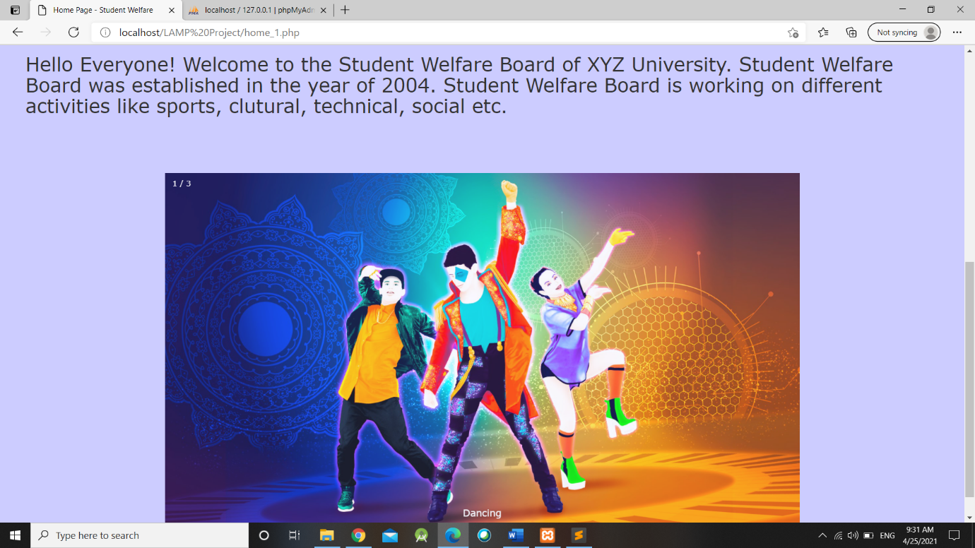

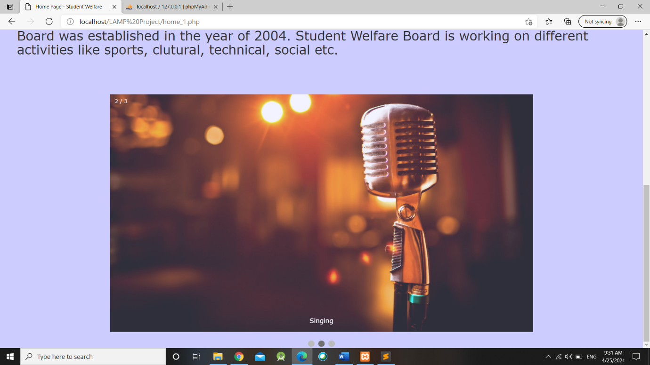

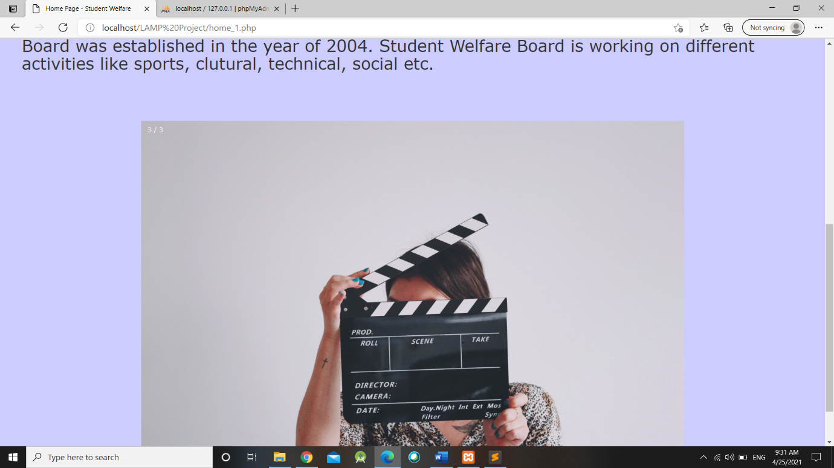

* 1. **Code**

<center> <h1> <strong style="color:#000033;"> Welcome to Student Welfare Board! </strong></h1> </center><br><br>

<div style="padding: 20px; margin: 20px;">

<p> <h2> Hello Everyone! Welcome to the Student Welfare Board of XYZ University. Student Welfare Board was established in the year of 2004. Student Welfare Board is working on different activities like sports, clutural, technical, social etc.</h2></p><br><br>

</div>

<div class="slideshow-container">

<div class="mySlides fade">

<div class="numbertext">1 / 3</div>

<img src="lp3.jpg" style="width:100%; height: 100%;">

<div class="text">Dancing</div>

</div>

<div class="mySlides fade">

<div class="numbertext">2 / 3</div>

<img src="lp4.jpg" style="width:100%; height: 100%;">

<div class="text">Singing</div>

</div>

<div class="mySlides fade">

<div class="numbertext">3 / 3</div>

<img src="lp5.jpg" style="width:100%;height: 100%;">

<div class="text">Acting</div>

</div>

</div>

<br>

<div style="text-align:center">

<span class="dot"></span>

<span class="dot"></span>

<span class="dot"></span>

</div>

<script>

var slideIndex = 0;

showSlides();

function showSlides() {

var i;

var slides = document.getElementsByClassName("mySlides");

var dots = document.getElementsByClassName("dot");

for (i = 0; i < slides.length; i++) {

slides[i].style.display = "none";

}

slideIndex++;

if (slideIndex > slides.length) {slideIndex = 1}

for (i = 0; i < dots.length; i++) {

dots[i].className = dots[i].className.replace(" active", "");

}

slides[slideIndex-1].style.display = "block";

dots[slideIndex-1].className += " active";

setTimeout(showSlides, 3000); // Change image every 2 seconds

}

</script>

</body>

</html>

1. **Registration Form**
   1. **Screenshots**

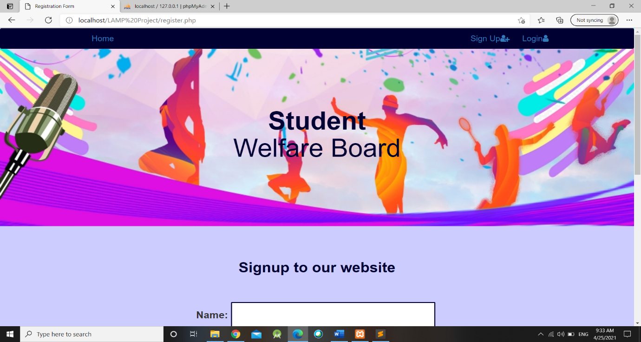

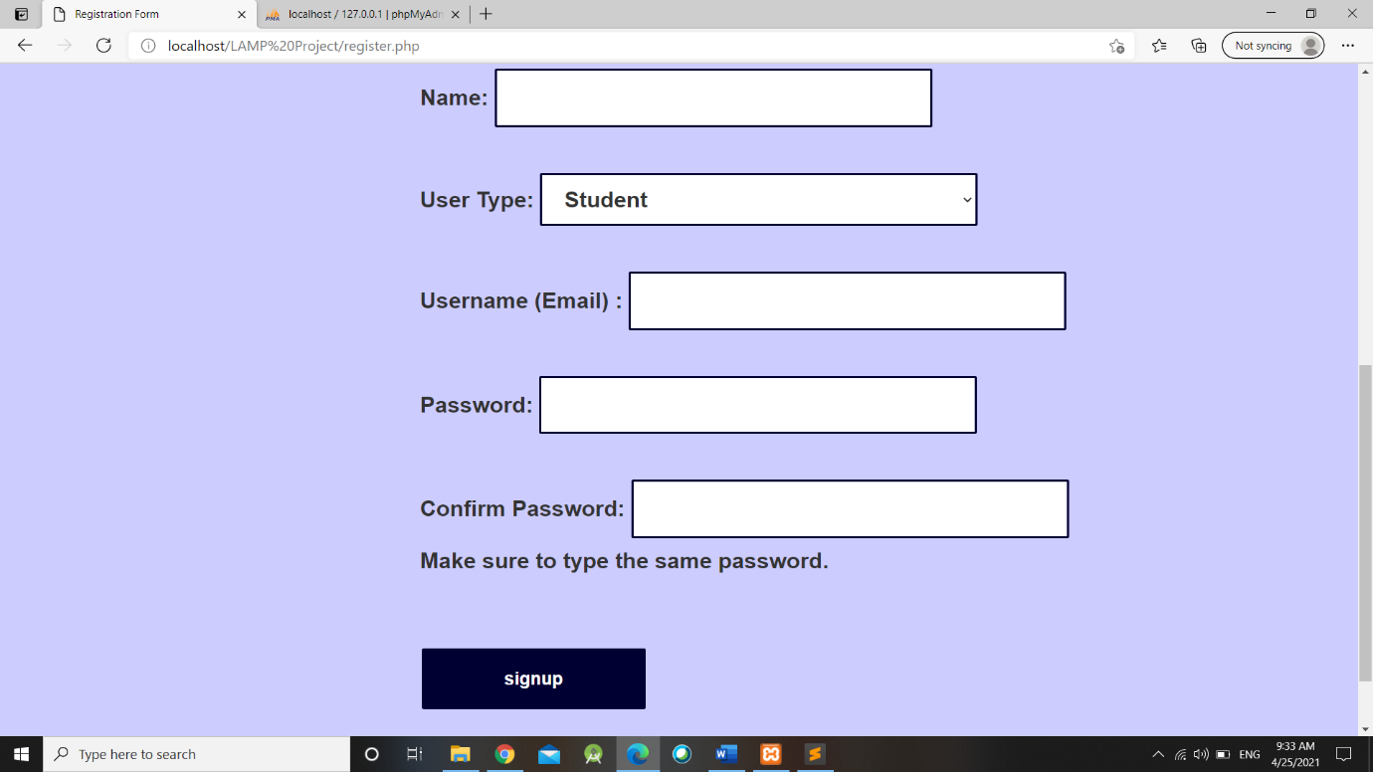

* 1. **Code**

<?php

$showAlert = false;

$showError=$showError_1=$showError_2=$showError_3 = false;

if($_SERVER["REQUEST_METHOD"] == "POST"){

function alertmsg($alt_msg)

{

echo("<script type='text/javascript'>

alert('".$alt_msg."'); </script>");

}

include_once('connection.php');

$name = $_POST['name'];

$username = $_POST['username'];

$password = $_POST['password'];

$cpassword = $_POST['cpassword'];

$utype = $_POST['utype'];

//$exists = false;

// Check whether the username exist

$existSql = "SELECT * FROM signup where username = '$username'";

// $existSql = "Select * from users where username='$username'";

$result = mysqli_query($conn, $existSql) or die( mysqli_error($conn));

$numExistRows = mysqli_num_rows($result);

if($numExistRows > 0) {

$showError = "Username already exists";

}

else{

if(!filter_var($username, FILTER_VALIDATE_EMAIL)){

$showError_1 = "Email is not valid";

}

else if(strlen($password) < 8){

$showError_2 = "Password is short (should be between 8 to 23 characters)";

}

else if($password == $cpassword)

{

$sql = "INSERT INTO signup (name, utype, username, password, dt) VALUES ('$name', '$utype', '$username', '$password', current_timestamp())";

$result = mysqli_query($conn, $sql);

if($result)

{

$nrows=mysqli_affected_rows($conn);

if($nrows>0)

{

$alt_msg = "Successfully Registered!";

$name = alertmsg($alt_msg);

echo '<script type="text/javascript"> window.location.href = "home_1.php" </script>';

//header("Location: http://localhost:8080/PHP6/8.html");

exit;

}

}

}

else{

$showError_3 = "Passwords do not match";

}

}

}

?>

<br> <br>

<center> <h1> <strong style="color:#000033;">Signup to our website </strong> </h1> </center>

<div id="ev_w">

<form action="register.php" method="post">

Name: <input type="text" name="name" required> <br><br>

User Type: <select name='utype' required><br><br>

<option value='Student'> Student </option>

<option value='Faculty'> Faculty </option>

<option value='Admin'> Admin </option>

</select><br><br>

Username (Email) : <input type="text" name="username" required> <span style="color: red;"><?php echo $showError; ?> <?php echo $showError_1; ?> </span> <br><br>

Password: <input type="password" name="password" required> <span style="color: red;"><?php echo $showError_2; ?> </span> <br><br>

Confirm Password: <input type="password" name="cpassword" required> <span style="color: red;"><?php echo $showError_3; ?> </span>

<div id="emailHelp" class="form-text">Make sure to type the same password.</div><br><br>

<input type="submit" value="signup">

</form>

</div>

</body>

</html>

1. **Login Form**
   1. **Screenshots**

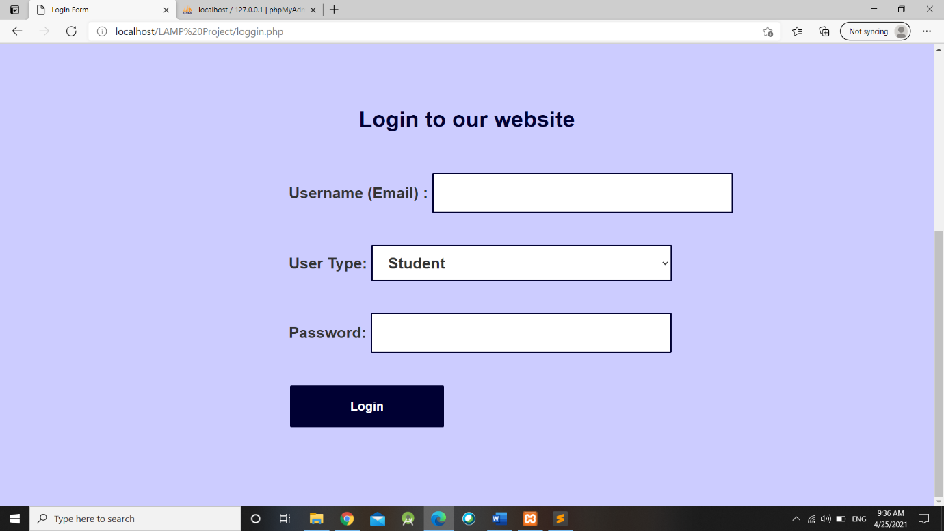

* 1. **Code**

<?php

session_start();

if(isset($_SESSION['loggedin']))

{

echo $_SESSION['username'] . "-" . $_SESSION['utype'];

}

?>

<?php

$login = false;

$showError = false;

include_once('connection.php');

if($_SERVER["REQUEST_METHOD"] == "POST"){

function alertmsg($alt_msg)

{

echo("<script type='text/javascript'>

alert('".$alt_msg."'); </script>");

}

$username = $_POST["username"];

$password = $_POST["password"];

$utype = $_POST["utype"];

$sql = "SELECT * FROM signup WHERE username='$username' AND password='$password' AND utype='$utype'";

$result = mysqli_query($conn, $sql);

$num = mysqli_num_rows($result);

if($num == 1)

{$login = true;

session_start();

$_SESSION['loggedin'] = true;

$_SESSION['username'] = $username;

$_SESSION['utype'] = $utype;

if($utype == 'Student')

{$alt_msg = "Successfully Login!";

$name = alertmsg($alt_msg);

echo '<script type="text/javascript">window.location.href = "home_1_student.php"; </script>';

}

if($utype == 'Admin')

{$alt_msg = "Successfully Login!";

$name = alertmsg($alt_msg);

echo '<script type="text/javascript">window.location.href = "home_1_admin.php"; </script>';

}

if($utype == 'Faculty')

{

$alt_msg = "Successfully Login!";

$name = alertmsg($alt_msg);

echo '<script type="text/javascript">window.location.href = "home_1_faculty.php"; </script>';

}

}

else{

$showError = "Invalid Credentials or User Type";

}

}

?>

<center><h2 style="color:red;"> <span><?php echo $showError; ?> </span></h2> </center> <br>

<br> <br>

<center> <h1> <strong style="color:#000033;">Login to our website </strong> </h1> </center>

<div id="ev_w">

<form action="loggin.php" method="post">

Username (Email) : <input type="text" name="username" required><br><br>

User Type: <select name='utype' required><br><br>

<option value='Student'> Student </option>

<option value='Faculty'> Faculty </option>

<option value='Admin'> Admin </option>

</select><br><br>

Password: <input type="password" name="password" required> <br><br>

<input type="submit" value="Login">

</form>

</div>

</body>

</html>

1. **logout.php**
   1. **Code**

<?php

session_start();

if(isset($_SESSION['loggedin']))

{function alertmsg($alt_msg)

{echo("<script type='text/javascript'>

alert('".$alt_msg."'); </script>");

}

$alt_msg = "Successfully Logout!";

$name = alertmsg($alt_msg);

echo '<script type="text/javascript">window.location.href = "home_1.php"; </script>';

}

session_unset();

session_destroy();

echo '<script type="text/javascript">window.location.href = "home_1.php"; </script>';

exit;

?>

1. **Student Welfare – Student** 
   1. **Screenshots**

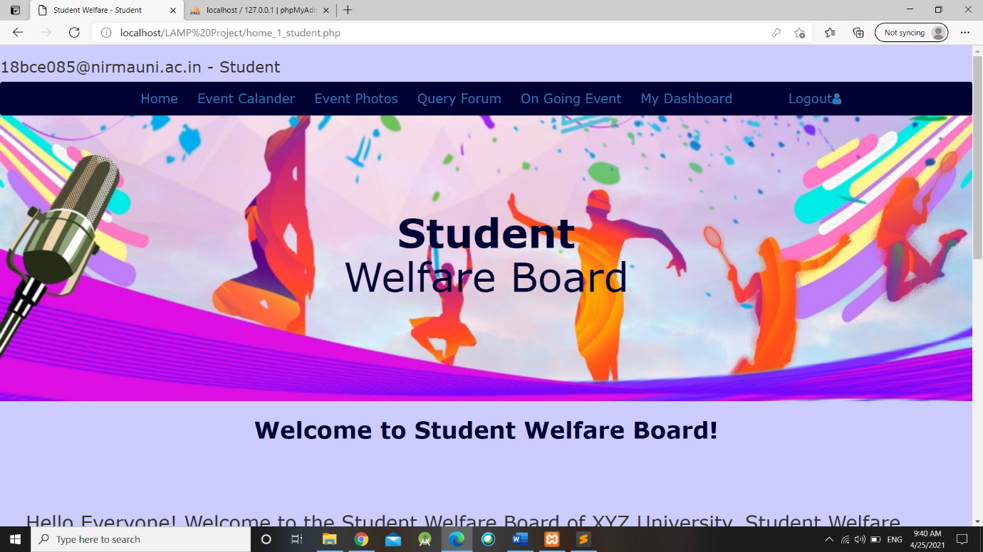

* 1. **Code**

<?php

session_start();

if(isset($_SESSION['loggedin']))

{

echo "<h3>". $_SESSION['username'] . " - " . $_SESSION['utype'] . "</h3>";

}

?>

<center> <h1> <strong style="color:#000033;"> Welcome to Student Welfare Board! </strong></h1> </center><br><br>

<div style="padding: 20px; margin: 20px;">

<p> <h2> Hello Everyone! Welcome to the Student Welfare Board of XYZ University. Student Welfare Board was established in the year of 2004. Student Welfare Board is working on different activities like sports, clutural, technical, social etc.</h2></p><br><br>

</div>

<div class="slideshow-container">

<div class="mySlides fade">

<div class="numbertext">1 / 3</div>

<img src="lp3.jpg" style="width:100%; height: 100%;">

<div class="text">Dancing</div>

</div>

<div class="mySlides fade">

<div class="numbertext">2 / 3</div>

<img src="lp4.jpg" style="width:100%; height: 100%;">

<div class="text">Singing</div>

</div>

<div class="mySlides fade">

<div class="numbertext">3 / 3</div>

<img src="lp5.jpg" style="width:100%;height: 100%;">

<div class="text">Acting</div>

</div>

</div>

<br>

<div style="text-align:center">

<span class="dot"></span>

<span class="dot"></span>

<span class="dot"></span>

</div>

<script>

var slideIndex = 0;

showSlides();

function showSlides() {

var i;

var slides = document.getElementsByClassName("mySlides");

var dots = document.getElementsByClassName("dot");

for (i = 0; i < slides.length; i++) {

slides[i].style.display = "none";

}

slideIndex++;

if (slideIndex > slides.length) {slideIndex = 1}

for (i = 0; i < dots.length; i++) {

dots[i].className = dots[i].className.replace(" active", "");

}

slides[slideIndex-1].style.display = "block";

dots[slideIndex-1].className += " active";

setTimeout(showSlides, 3000); // Change image every 2 seconds

}

</script>

</body>

</html>

1. **Event Calendar for Students** 
   1. **Screenshots**

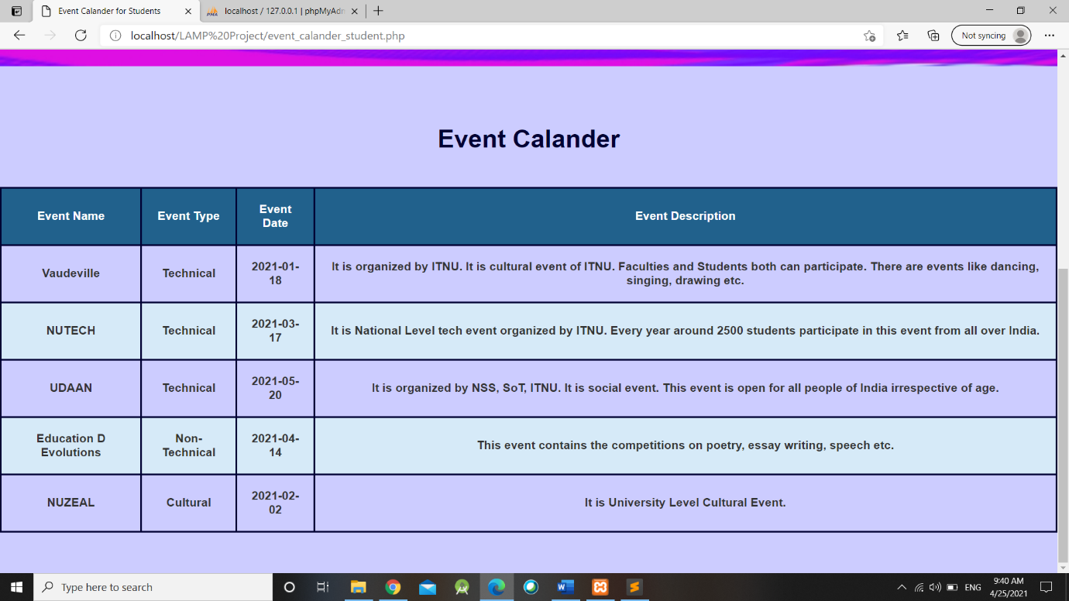

* 1. **Code**

<?php

session_start();

if(isset($_SESSION['loggedin']))

{

echo "<h3>". $_SESSION['username'] . " - " . $_SESSION['utype'] . "</h3>";

}

?>

<?php

include_once('connection.php');

$query = "select * from event_calander";

$result = mysqli_query($conn, $query);

?><br> <br>

<center> <h1> <strong style="color:#000033;"> Event Calander </strong> </h1> <br> <br>

<table>

<tr>

<th> Event Name </th>

<th> Event Type </th>

<th> Event Date </th>

<th> Event Description </th>

</tr>

<?php

while($row = mysqli_fetch_array($result))

{

echo "<tr>";

echo "<td>" . $row['event_name'] ."</td>";

echo "<td>" . $row['event_type'] ."</td>";

echo "<td>" . $row['event_month'] ."</td>";

echo "<td>" . $row['event_desc'] ."</td>";

echo "</tr>";}?>

</table> </center>

<br> <br><br>

</body>

</html>

1. **Images of Events for Student**
   1. **Screenshots**

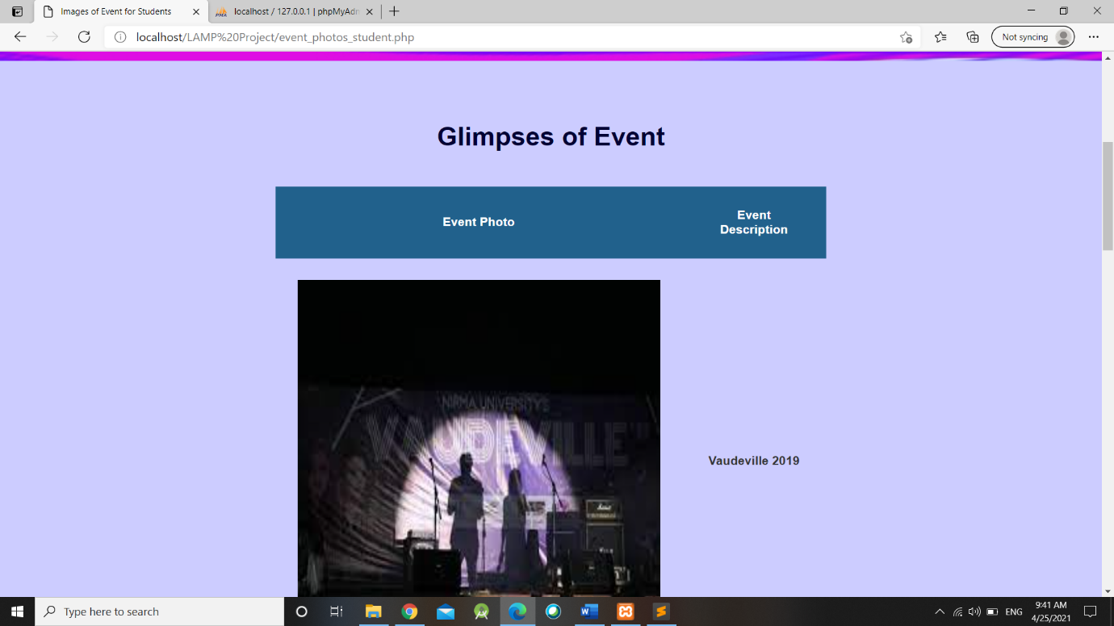

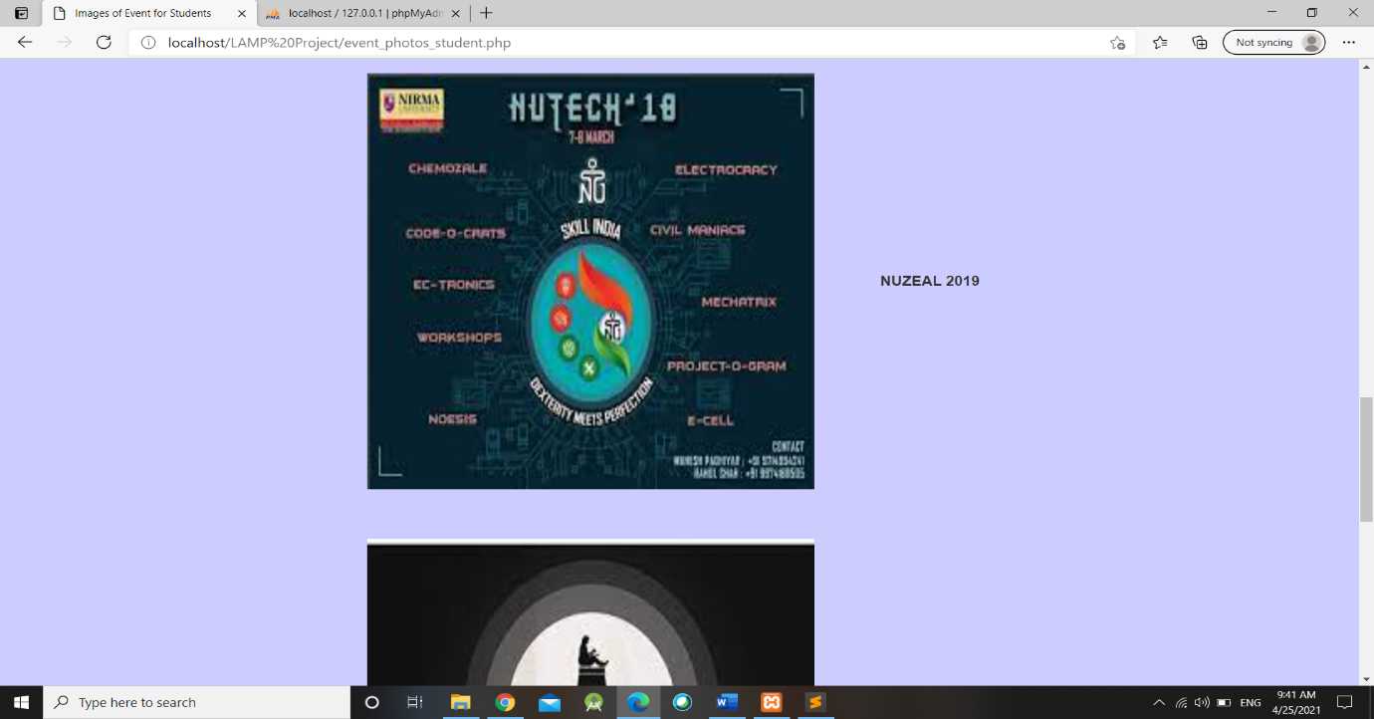

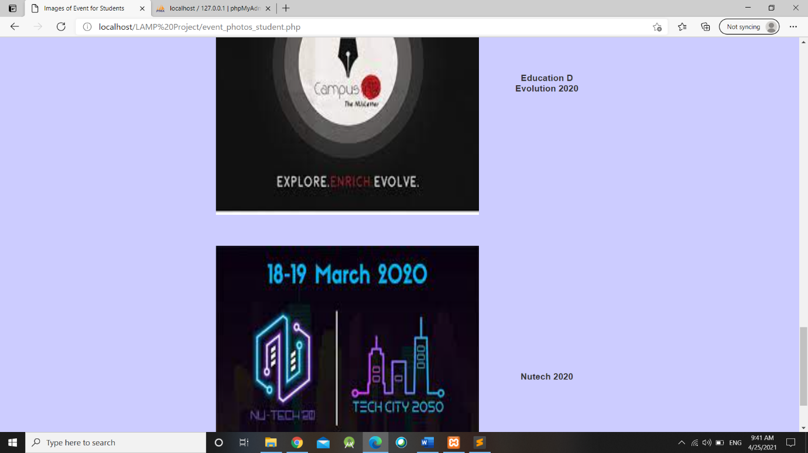

* 1. **Code**

<?php

session_start();

if(isset($_SESSION['loggedin']))

{

echo "<h3>". $_SESSION['username'] . " - " . $_SESSION['utype'] . "</h3>";

}

?>

<?php

include_once('connection.php');

$query = "select * from event_images";

$result = mysqli_query($conn, $query);

?>

<br> <br>

<center> <h1> <strong style="color:#000033;"> Glimpses of Event </strong> </h1> <br> <br>

<table>

<tr>

<th> Event Photo</th>

<th> Event Description</th>

</tr>

<?php

$query = "SELECT * from event_images";

$result = mysqli_query($conn, $query);

while($row = mysqli_fetch_array($result))

{ ?>

<tr>

<td> <img src ="Event_Photos/<?php echo $row['image_path'];?>" style="width:500px;height: 500px;"> </td>

<td> <?php echo $row['image_desc'];?> </td>

</tr>

<?php}?>

</table>

</center>

</body>

</html>

1. **Query Forum** 
   1. **Screenshots**

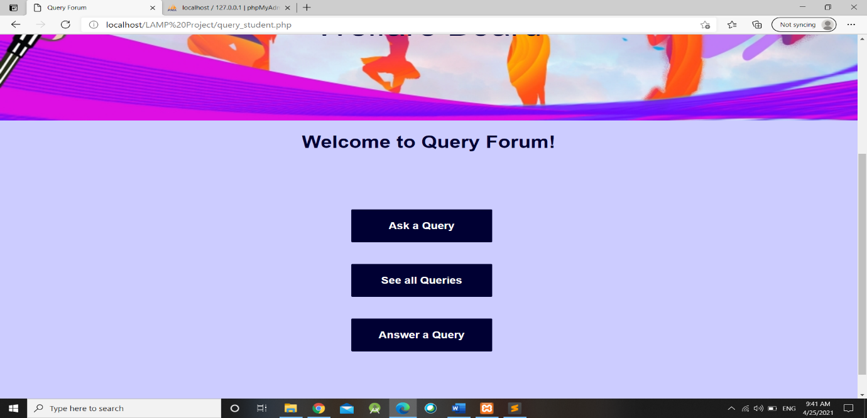

* 1. **Code**

<?php

session_start();

if(isset($_SESSION['loggedin']))

{

echo "<h3>". $_SESSION['username'] . " - " . $_SESSION['utype'] . "</h3>";

}

?>

<center> <h1><strong style="color:#000033;"> Welcome to Query Forum! </strong> </h1><br> <br> </center>

<div id="ev_w">

<form method="post" action="ask_query.php">

<input type="submit" name="ask" value="Ask a Query">

</form>

<form method="post" action="see_query.php">

<input type="submit" name="see" value="See all Queries">

</form>

<form method="post" action="answer_query.php">

<input type="submit" name="answer" value="Answer a Query">

</form>

</div>

</body>

</body>

</html>

1. **Ask Question**
   1. **Screenshots**

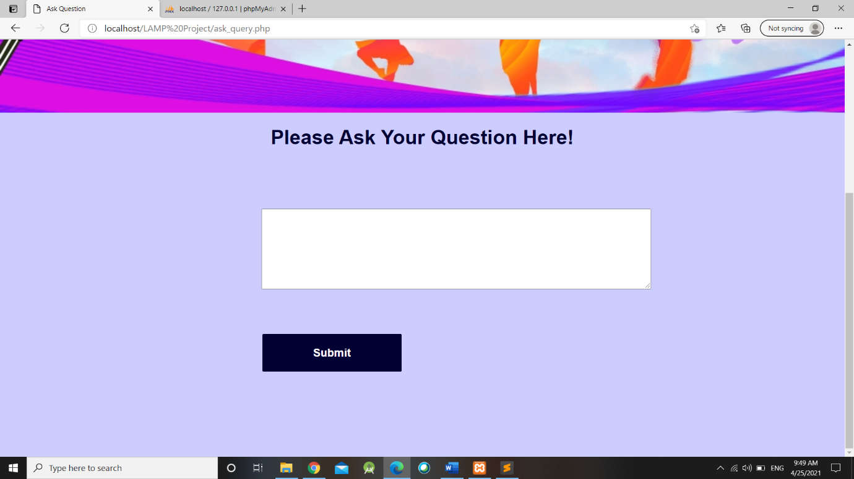

* 1. **Code**

<?php

session_start();

if(isset($_SESSION['loggedin']))

{

$u = $_SESSION['username'];

echo "<h3>". $_SESSION['username'] . " - " . $_SESSION['utype'] . "</h3>";

}

?>

<center> <h1><strong style="color:#000033;"> Please Ask Your Question Here! </strong> </h1><br> <br> </center>

<?php

include_once('connection.php');

?>

<?php

if (isset($_POST['ask']))

{

?>

<div id="ev_w">

<form method="post" action="ask_query.php" onsubmit="return func()">

<textarea rows="4" cols="50" name="query" id="query" autocomplete="off"></textarea>

<div id="div1"></div><br><br>

<input type="submit" name="askquery" value="Submit">

</form>

</div>

<script type="text/javascript">

function func()

{

var query = document.getElementById('query').value;

if(query == "")

{

document.getElementById('div1').innerHTML = "** Please fill the query field.";

document.getElementById('div1').style.color = "Red";

return false;

}

}

</script>

<?php

}

?>

<?php

if (isset($_POST['askquery']))

{ function alertmsg($alt_msg)

{

echo("<script type='text/javascript'>

alert('".$alt_msg."'); </script>");

}

$query_ask = $_POST["query"];

$query = "INSERT INTO query_answer(query_id, query_user, query_ask) VALUES ('','$u','$query_ask')";

$result = mysqli_query($conn, $query);

if ($result)

{ $nrows=mysqli_affected_rows($conn);

if($nrows>0)

{

$alt_msg = "Query Raised Successfully!";

$name = alertmsg($alt_msg);

echo '<script type="text/javascript">window.location.href = "query_student.php"; </script>';

//header("Location: http://localhost:8080/PHP6/8.html");

exit;

}

}

}

?>

</body>

</body>

</html>

1. **All the Queries** 
   1. **Screenshots**

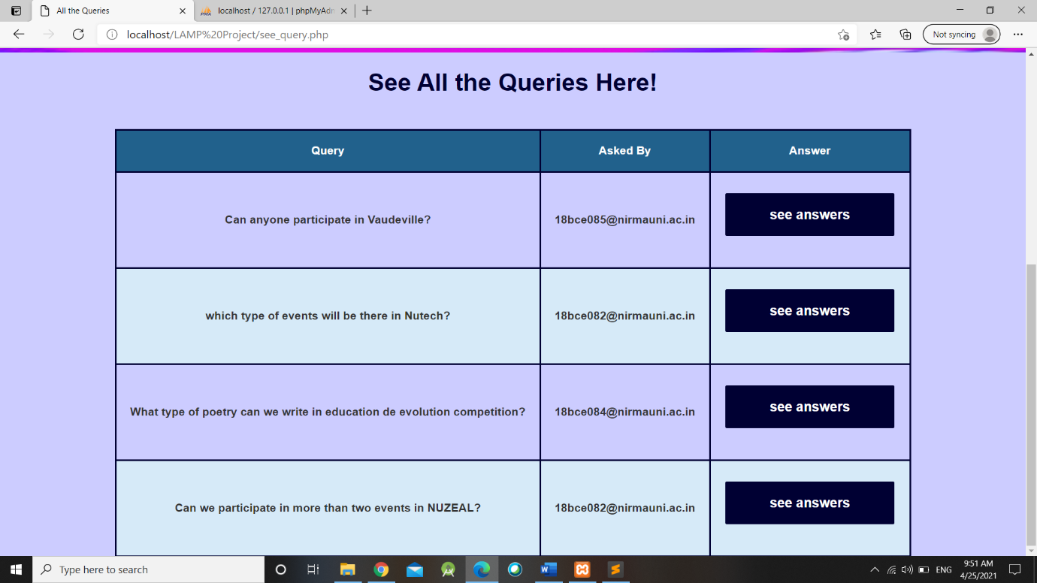

* 1. **Code**

<?php

session_start();

if(isset($_SESSION['loggedin']))

{

echo "<h3>". $_SESSION['username'] . " - " . $_SESSION['utype'] . "</h3>";

}

?>

<center> <h1><strong style="color:#000033;"> See All the Queries Here! </strong> </h1><br> <br>

<?php

include_once('connection.php');

?>

<?php

if (isset($_POST['see']))

{

$query = "SELECT * FROM query_answer";

$result = mysqli_query($conn, $query);

?>

<table>

<th>Query</th>

<th>Asked By </th>

<th>Answer</th>

</tr>

<?php

// output data of each row

while($row = mysqli_fetch_array($result))

{ ?>

<tr>

<td> <?php echo $row["query_ask"];?> </td>

<td> <?php echo $row["query_user"];?> </td>

<td><form method="post" action="see_query_answer.php">

<input type="hidden" name="query_id" value="<?php echo $row['query_id']; ?>">

<input type="hidden" name="query_value" value="<?php echo $row['query_ask']; ?>">

<input type="submit" name="see_answer" value="see answers">

</form></td>

</td>

</tr>

<?php

}

echo "</table>";

?>

</center>

</table>

</body>

</body>

</html>

1. **All the Answers** 
   1. **Screenshots**

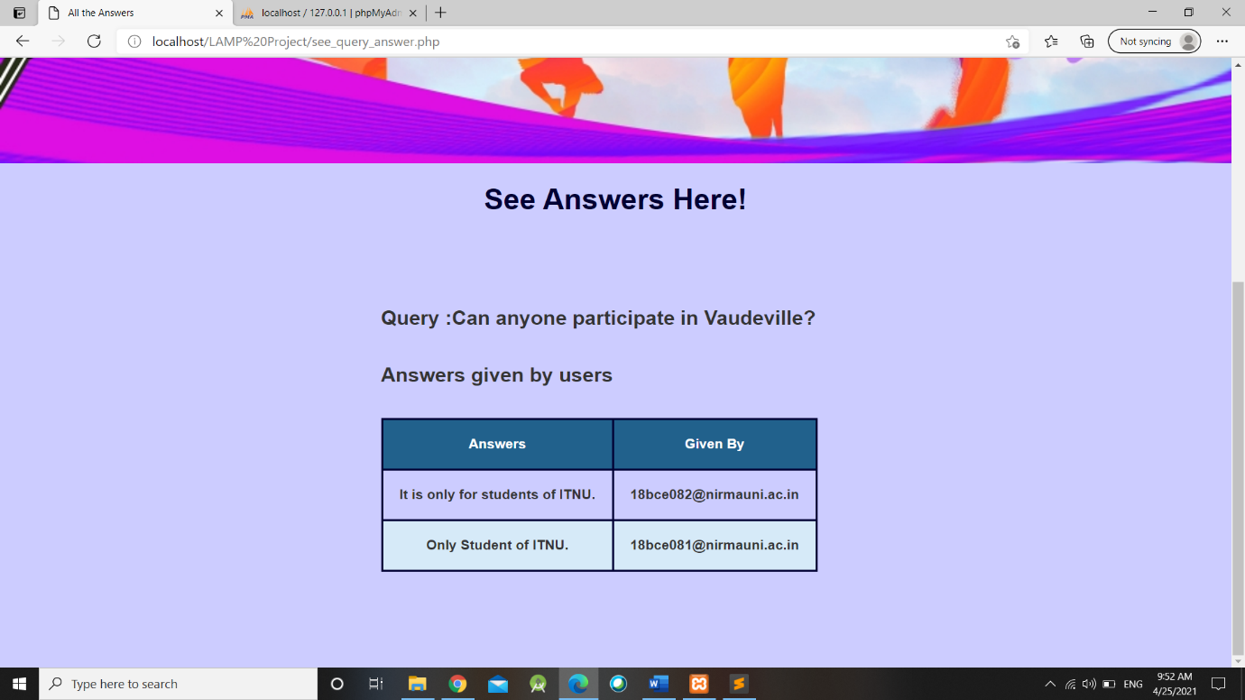

* 1. **Code**

<?php

session_start();

if(isset($_SESSION['loggedin']))

{

echo "<h3>". $_SESSION['username'] . " - " . $_SESSION['utype'] . "</h3>";

}

?>

<center> <h1><strong style="color:#000033;"> See Answers Here! </strong> </h1><br> <br> </center>

<?php

include_once('connection.php');

?>

<?php

if(isset($_POST['see_answer']))

{$ask_query = $_POST['query_value'];

$id = $_POST['query_id'];

?>

<div id="ev_w">

<b>Query :</b><?php echo $ask_query; ?> <br><br>

<b>Answers given by users<br><br></b>

<?php

$query = "SELECT * FROM query_answer_answer WHERE question_id = '$id'";

$result = mysqli_query($conn, $query);

if (mysqli_num_rows($result) > 0)

{

?>

<table>

<tr>

<th>Answers</th>

<th>Given By </th>

</tr>

<?php

$count=1;

while($row = mysqli_fetch_array($result))

{

?>

<tr>

<td> <?php echo $row['answer']; ?></td>

<td> <?php echo $row['answer_user'];?></td>

</tr>

<?php

$count = $count + 1;

}

echo "</table>";

}

else

{

?>

<table> <tr> <td><center> <h1><strong style="color:#000033;"> No Answers</strong></h1></center> </td></tr></table>

<?php

}

echo "</div>";

}

?>

</table>

</div>

</body>

</body>

</html>

1. **Answer the Question** 
   1. **Screenshots**

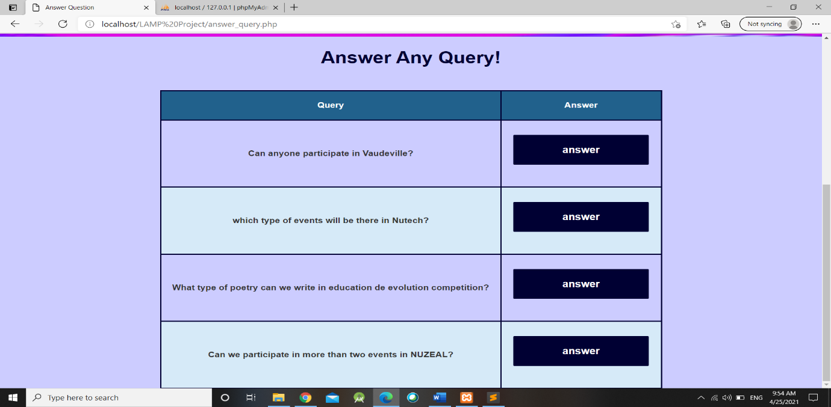

* 1. **Code**

<?php

session_start();

if(isset($_SESSION['loggedin']))

{

echo "<h3>". $_SESSION['username'] . " - " . $_SESSION['utype'] . "</h3>";

}

?>

<center> <h1><strong style="color:#000033;"> Answer Any Query! </strong> </h1><br> <br>

<?php

include_once('connection.php');

?>

<?php

if (isset($_POST['answer']))

{

$query = "SELECT * FROM query_answer";

$result = mysqli_query($conn, $query);

?>

<table>

<tr>

<th>Query</th>

<th>Answer</th>

</tr>

<?php

// output data of each row

while($row = mysqli_fetch_array($result))

{

?>

<tr>

<td> <?php echo $row['query_ask']; ?> </td>

<td><form method="post" action="answer_query_form.php">

<input type="hidden" name="id" value="<?php echo $row['query_id']; ?>">

<input type="hidden" name="query" value="<?php echo $row['query_ask']; ?>">

<input type="submit" name="answer" value="answer">

</form></td></tr>

<?php

}

echo "</table>";

}

?>

</center>

</body>

</body>

</html>

1. **Answer Form for Query** 
   1. **Screenshots**

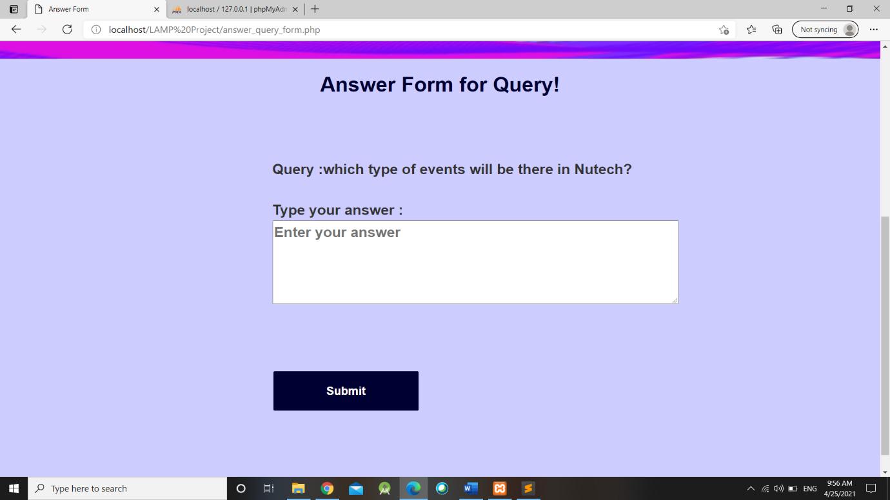

* 1. **Code**

<?php

session_start();

if(isset($_SESSION['loggedin']))

{

$u = $_SESSION['username'];

echo "<h3>". $_SESSION['username'] . " - " . $_SESSION['utype'] . "</h3>";

}

?>

<center> <h1><strong style="color:#000033;"> Answer Form for Query! </strong> </h1><br> <br> </center>

<?php

include_once('connection.php');

?>

<?php

if(isset($_POST["answer"]))

{

$ans_id = $_POST['id'];

$ask_query = $_POST['query'];

?>

<div id="ev_w">

<b>Query :</b><?php echo $ask_query; ?> <br><br>

<form method="post" action="answer_query_form.php" onsubmit="return func()">

<b>Type your answer :</b> <br><textarea rows="4" cols="50" name="ans" id="ans" placeholder="Enter your answer" autocomplete="off"></textarea>

<br><br>

<div id="div1"></div><br><br>

<input type="hidden" name="ans_id" value="<?php echo $ans_id; ?>">

<input type="submit" name="ans_query" value="Submit">

</form>

</div>

<script type="text/javascript">

function func()

{

var ans = document.getElementById('ans').value;

if(ans == "")

{

document.getElementById('div1').innerHTML = "** Please fill the answer field.";

document.getElementById('div1').style.color = "Red";

return false;

}

}

</script>

<?php

}

?>

<?php

if(isset($_POST["ans_query"]))

{

$id = $_POST['ans_id'];

$ans = $_POST['ans'];

function alertmsg($alt_msg)

{

echo("<script type='text/javascript'>

alert('".$alt_msg."'); </script>");

}

$query = "INSERT INTO query_answer_answer(question_id, answer_user, answer) VALUES ('$id', '$u','$ans')";

$result = mysqli_query($conn, $query);

if ($result)

{

$nrows=mysqli_affected_rows($conn);

if($nrows>0)

{

$alt_msg = "Query Answered Successfully!";

$name = alertmsg($alt_msg);

echo '<script type="text/javascript">';

echo 'window.location.href = "query_student.php";';

echo '</script>';

//header("Location: http://localhost:8080/PHP6/8.html");

exit;

}

}

}

?>

</body>

</body>

</html>

1. **Ongoing Events – Student** 
   1. **Screenshots**

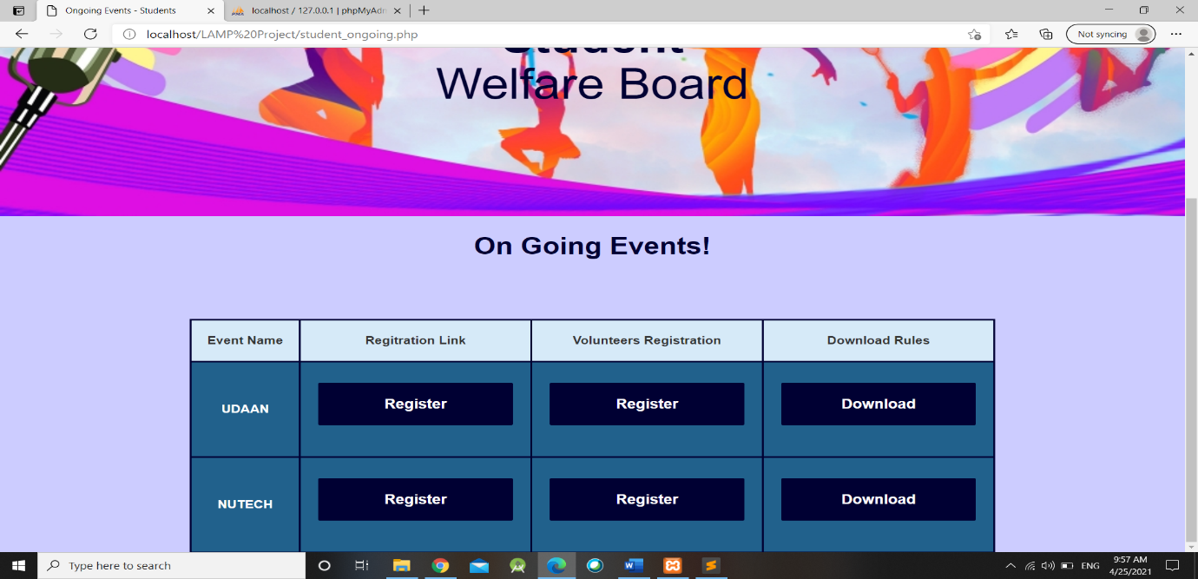

* 1. **Code**

<?php

session_start();

if(isset($_SESSION['loggedin']))

{

echo "<h3>". $_SESSION['username'] . " - " . $_SESSION['utype'] . "</h3>";

}

?>

<body>

<center> <h1><strong style="color:#000033;"> On Going Events! </strong> </h1><br> <br>

<br><br>

<table>

<tr>

<td> Event Name </td>

<td> Regitration Link </td>

<td> Volunteers Registration </td>

<td> Download Rules </td>

</tr>

<?php

while($row = mysqli_fetch_array($result))

{

$id = $row['on_id'];

?>

<tr>

<th> <?php echo $row['on_name'];?> </th>

<th> <form action="register_event.php" method="post">

<input type="hidden" value="<?php echo $id ;?>" name="e_id">

<input type="submit" value="Register" name="on_register">

</form></th>

<th> <form action="volunteers_registration.php" method="post">

<input type="hidden" value="<?php echo $id ;?>" name="e_id">

<input type="submit" value="Register" name="on_register_vol">

</form></th>

<th> <form action="download.php" method="post">

<input type="hidden" value="<?php echo $id ;?>" name="e_id">

<input type="submit" value="Download" name="download">

</form></th>

</tr>

<?php

}

echo "</table>";

?>

</center>

</body>

</html>

1. **download.php**
   1. **Code**

<?php

include_once('connection.php');

if(isset($_POST['download']))

{

$eid = $_POST['e_id'];

$query = "SELECT * from on_going_event WHERE on_id = '$eid'";

$result = mysqli_query($conn, $query);

while($row = mysqli_fetch_array($result))

{

$filepath = 'C:/xampp/htdocs/Practicals/LAMP Project/Event_Rules/' . $row['on_pdf'];

if (file_exists($filepath))

{

header('Content-Description: File Transfer');

header('Content-Type: application/octet-stream');

header('Content-Disposition: attachment; filename=' . basename($filepath));

header('Expires: 0');

header('Cache-Control: must-revalidate');

header('Pragma: public');

header('Content-Length: ' . filesize('C:/xampp/htdocs/Practicals/LAMP Project/Event_Rules/' . $row['on_pdf']));

readfile('C:/xampp/htdocs/Practicals/LAMP Project/Event_Rules/' . $row['on_pdf']);

// Now update downloads count

$newCount = $file['downloads'] + 1;

$updateQuery = "UPDATE files SET downloads=$newCount WHERE id=$id";

mysqli_query($conn, $updateQuery);

}

}

}

?>

1. **Ongoing Events Registration**
   1. **Screenshots**

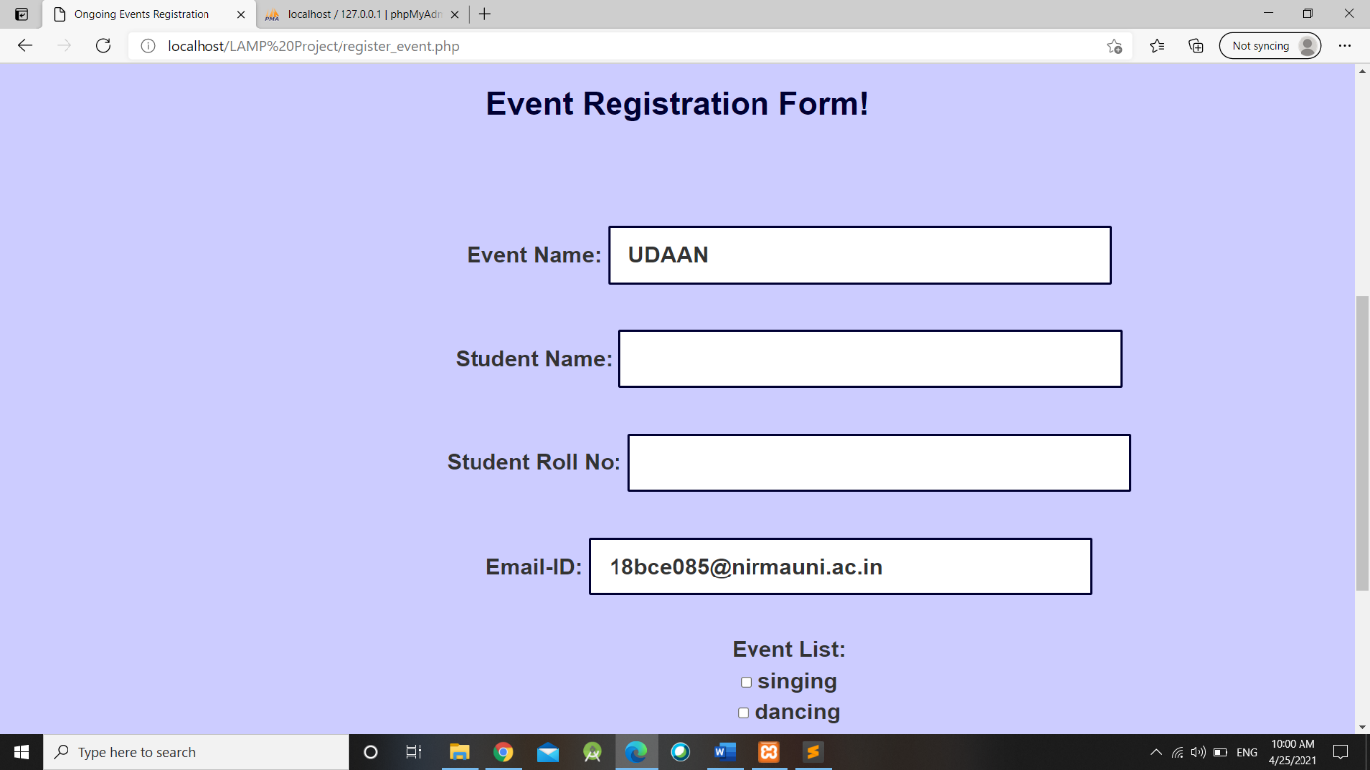

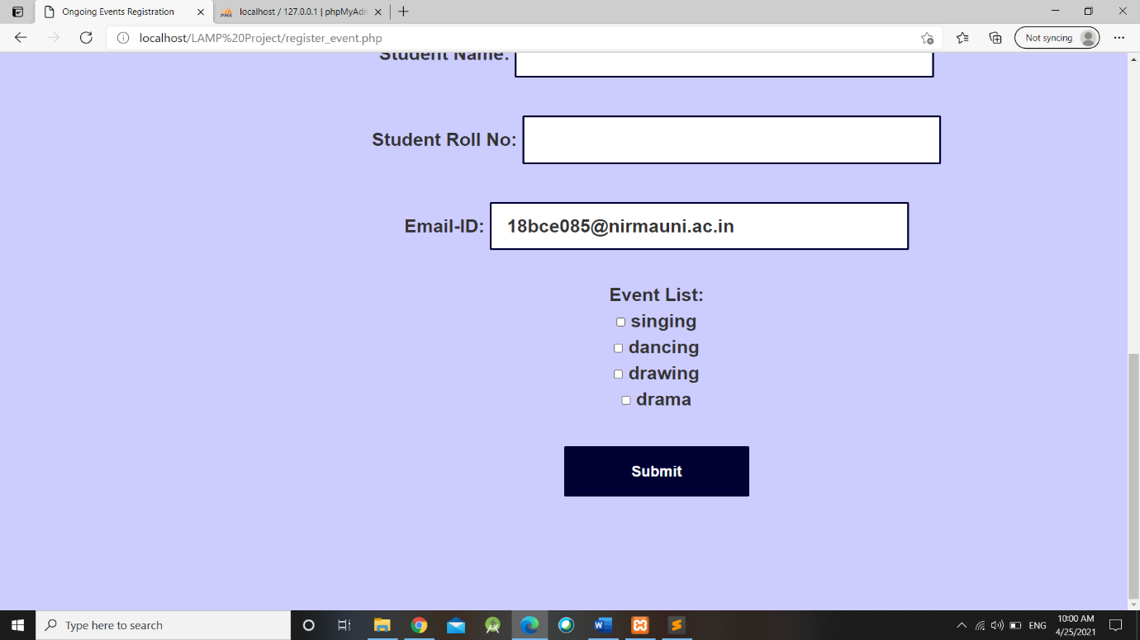

* 1. **Code**

<?php

session_start();

if(isset($_SESSION['loggedin']))

{

$u = $_SESSION['username'];

echo "<h3>". $_SESSION['username'] . " - " . $_SESSION['utype'] . "</h3>";

}

?>

<?php

include_once('connection.php');

if(isset($_POST['on_register']))

{

$eid = $_POST['e_id'];

$query = "SELECT * from on_going_event WHERE on_id = '$eid'";

$result = mysqli_query($conn, $query);

}

?>

<center> <h1><strong style="color:#000033;"> Event Registration Form! </strong> </h1><br> <br>

<div id="ev_w">

<form method="post" action= "register_event_verify.php">

<?php

while($row = mysqli_fetch_array($result))

{

$e_name = $row['on_name'];

$e_subname = $row['on_subname'];

$e_subname = explode(",", $e_subname);

?>

Event Name: <input type="text" name="e_name" value="<?php echo $e_name;?>" readonly><br><br>

Student Name: <input type="text" name="name" required>

<br><br>

Student Roll No: <input type="text" name="r_name" required>

<br><br>

Email-ID: <input type="text" name="email" value="<?php echo $u; ?>" readonly required>

<br><br>

Event List:<br>

<?php

foreach($e_subname as $e)

{

?>

<input type="checkbox" name="check_list[]" value="<?php echo $e; ?>"> <?php echo $e; ?> <br>

<?php

}

?>

<br>

<input type="submit" name="submit" value="Submit">

</form>

</div>

<?php

}

?>

</center>

</body>

</html>

1. **register_event_verify.php**
   1. **Code**

<?php

include_once('connection.php');

$name = $e_name = $r_name = $email= "";

if (isset($_POST['submit']))

{

function alertmsg($alt_msg)

{

echo("<script type='text/javascript'>

alert('".$alt_msg."'); </script>");

}

$name = test_input($_POST["name"]);

$e_name = test_input($_POST["e_name"]);

$r_name = test_input($_POST["r_name"]);

$email = test_input($_POST["email"]);

$e_subname = $_POST["check_list"];

$e_subname = implode(",", $e_subname);

$query = "INSERT INTO event_registration(e_name, s_name, s_roll, s_email, r_subname) VALUES('$e_name','$name','$r_name','$email','$e_subname')";

$result = mysqli_query($conn, $query);

if($result)

{

$alt_msg = "Successfully Registered in Event!";

$name = alertmsg($alt_msg);

echo '<script type="text/javascript">window.location.href = "student_ongoing.php"; </script>';

}

}

function test_input($data)

{

$data = trim($data);

$data = stripslashes($data);

$data = htmlspecialchars($data);

return $data;

}?>

1. **Volunteers Registration Form** 
   1. **Screenshots**

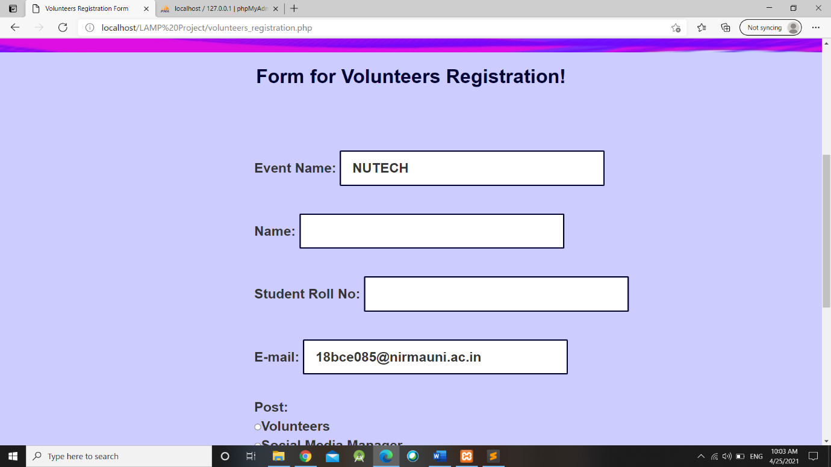

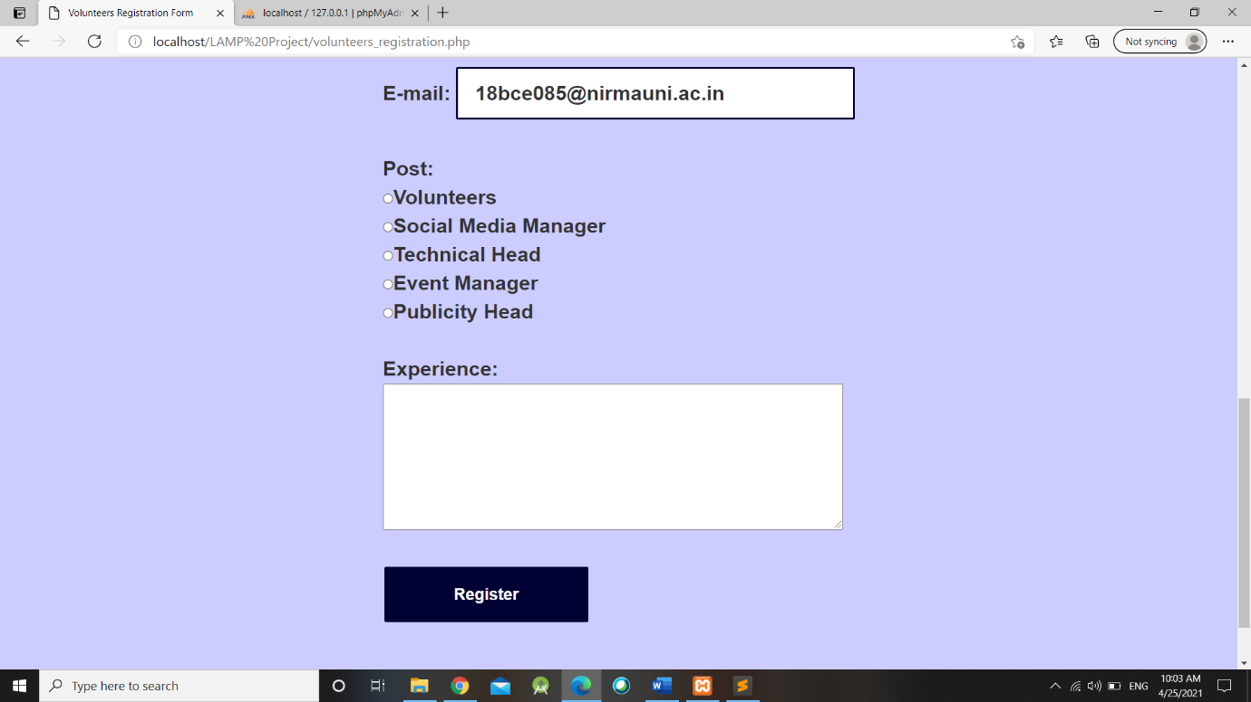

* 1. **Code**

<?php

session_start();

if(isset($_SESSION['loggedin']))

{

$u = $_SESSION['username'];

echo "<h3>". $_SESSION['username'] . " - " . $_SESSION['utype'] . "</h3>";

}

?>

<center> <h1><strong style="color:#000033;"> Form for Volunteers Registration! </strong> </h1><br> <br> </center>

<?php

include_once('connection.php');

if(isset($_POST['on_register_vol']))

{

$eid = $_POST['e_id'];

$query = "SELECT * from on_going_event WHERE on_id = '$eid'";

$result = mysqli_query($conn, $query);

}

?>

<div id="ev_w">

<?php

while($row = mysqli_fetch_array($result))

{

$e_name = $row['on_name'];

?>

<form action='volunteers_registration_veify.php' method='post'>

Event Name: <input type="text" name="e_name" value="<?php echo $e_name;?>" readonly><br><br>

Name: <input type="text" name="name" required><br><br>

Student Roll No: <input type="text" name="r_name" required>

<br><br>

E-mail: <input type="text" name="email" value="<?php echo $u; ?>" readonly required><br><br>

Post:<br>

<input type="radio" name="post" value="Volunteers" required>Volunteers<br>

<input type="radio" name="post" value="Social Media Manager">Social Media Manager<br>

<input type="radio" name="post" value="Technical Head">Technical Head<br>

<input type="radio" name="post" value="Event Manager">Event Manager<br>

<input type="radio" name="post" value="Publicity Head">Publicity Head

<br><br>

Experience:<br> <textarea name="experience" rows="5" cols="40" required></textarea>

<br><br>

<input type="submit" name="v_re" value="Register">

</form>

<?php

}

?>

</div>

</body>

</body>

</html>

1. **volunteers_registration_verify.php**
   1. **Code**

<?php

include_once('connection.php');

if (isset($_POST['v_re']))

{

function alertmsg($alt_msg)

{

echo("<script type='text/javascript'>

alert('".$alt_msg."'); </script>");

}

$name = test_input($_POST["name"]);

$e_name = test_input($_POST["e_name"]);

$r_name = test_input($_POST["r_name"]);

$email = test_input($_POST["email"]);

$post = test_input($_POST["post"]);

$experience = test_input($_POST["experience"]);

$query = "INSERT INTO event_volunteers(v_ename, v_sname, v_rname, v_email, v_post, v_exp) VALUES('$e_name', '$name', '$r_name', '$email', '$post', '$experience')";

$result = mysqli_query($conn, $query);

if($result)

{

$alt_msg = "Successfully Registered for Volunteers!";

$name = alertmsg($alt_msg);

echo '<script type="text/javascript">window.location.href = "student_ongoing.php"; </script>';

}

}

function test_input($data)

{

$data = trim($data);

$data = stripslashes($data);

$data = htmlspecialchars($data);

return $data;

}

?>

1. **Dashboard – Student** 
   1. **Screenshots**

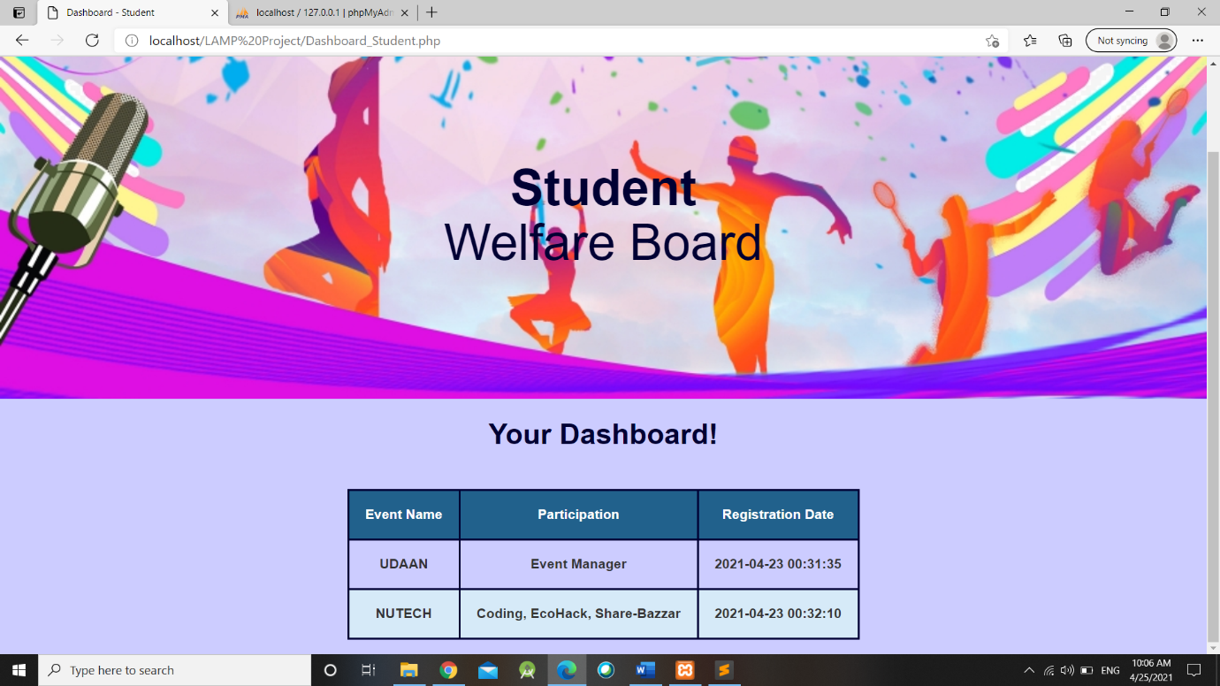

* 1. **Code**

<?php

session_start();

if(isset($_SESSION['loggedin']))

{

$u = $_SESSION['username'];

echo "<h3>". $_SESSION['username'] . " - " . $_SESSION['utype'] . "</h3>";

}

?>

<center> <h1><strong style="color:#000033;"> Your Dashboard! </strong> </h1><br> <br>

<?php

include_once('connection.php');

$query = "SELECT * from event_volunteers WHERE v_email = '$u'";

$query_1 = "SELECT * from event_registration WHERE s_email = '$u'";

$result = mysqli_query($conn, $query);

$result_1 = mysqli_query($conn, $query_1);

?>

<table>

<tr>

<th> Event Name </th>

<th> Participation </th>

<th> Registration Date </th>

</tr>

<?php

while($row = mysqli_fetch_array($result))

{

?>

<tr>

<td> <?php echo $row['v_ename'] ?> </td>

<td> <?php echo $row['v_post'] ?> </td>

<td> <?php echo $row['v_time'] ?> </td>

</tr>

<?php

}

while($row = mysqli_fetch_array($result_1))

{

?>

<tr>

<td> <?php echo $row['e_name'] ?> </td>

<td> <?php echo $row['r_subname'] ?> </td>

<td> <?php echo $row['r_time'] ?> </td>

</tr>

<?php

}

echo "</table>";?></center></br>

1. **Home Page – Faculty** 
   1. **Screenshots**



* 1. **Code**

<?php

session_start();

if(isset($_SESSION['loggedin']))

{

echo "<h3>". $_SESSION['username'] . " - " . $_SESSION['utype'] . "</h3>";

}

?>

<center> <h1> <strong style="color:#000033;"> Welcome to Student Welfare Board! </strong></h1> </center><br><br>

<div style="padding: 20px; margin: 20px;">

<p> <h2> Hello Everyone! Welcome to the Student Welfare Board of XYZ University. Student Welfare Board was established in the year of 2004. Student Welfare Board is working on different activities like sports, clutural, technical, social etc.</h2></p><br><br>

</div>

<div class="slideshow-container">

<div class="mySlides fade">

<div class="numbertext">1 / 3</div>

<img src="lp3.jpg" style="width:100%; height: 100%;">

<div class="text">Dancing</div>

</div>

<div class="mySlides fade">

<div class="numbertext">2 / 3</div>

<img src="lp4.jpg" style="width:100%; height: 100%;">

<div class="text">Singing</div>

</div>

<div class="mySlides fade">

<div class="numbertext">3 / 3</div>

<img src="lp5.jpg" style="width:100%;height: 100%;">

<div class="text">Acting</div>

</div>

</div>

<br>

<div style="text-align:center">

<span class="dot"></span>

<span class="dot"></span>

<span class="dot"></span>

</div>

<script>

var slideIndex = 0;

showSlides();

function showSlides() {

var i;

var slides = document.getElementsByClassName("mySlides");

var dots = document.getElementsByClassName("dot");

for (i = 0; i < slides.length; i++) {

slides[i].style.display = "none";

}

slideIndex++;

if (slideIndex > slides.length) {slideIndex = 1}

for (i = 0; i < dots.length; i++) {

dots[i].className = dots[i].className.replace(" active", "");

}

slides[slideIndex-1].style.display = "block";

dots[slideIndex-1].className += " active";

setTimeout(showSlides, 3000); // Change image every 2 seconds

}

</script>

</body>

</html>

1. **Add on going event**
   1. **Screenshots**

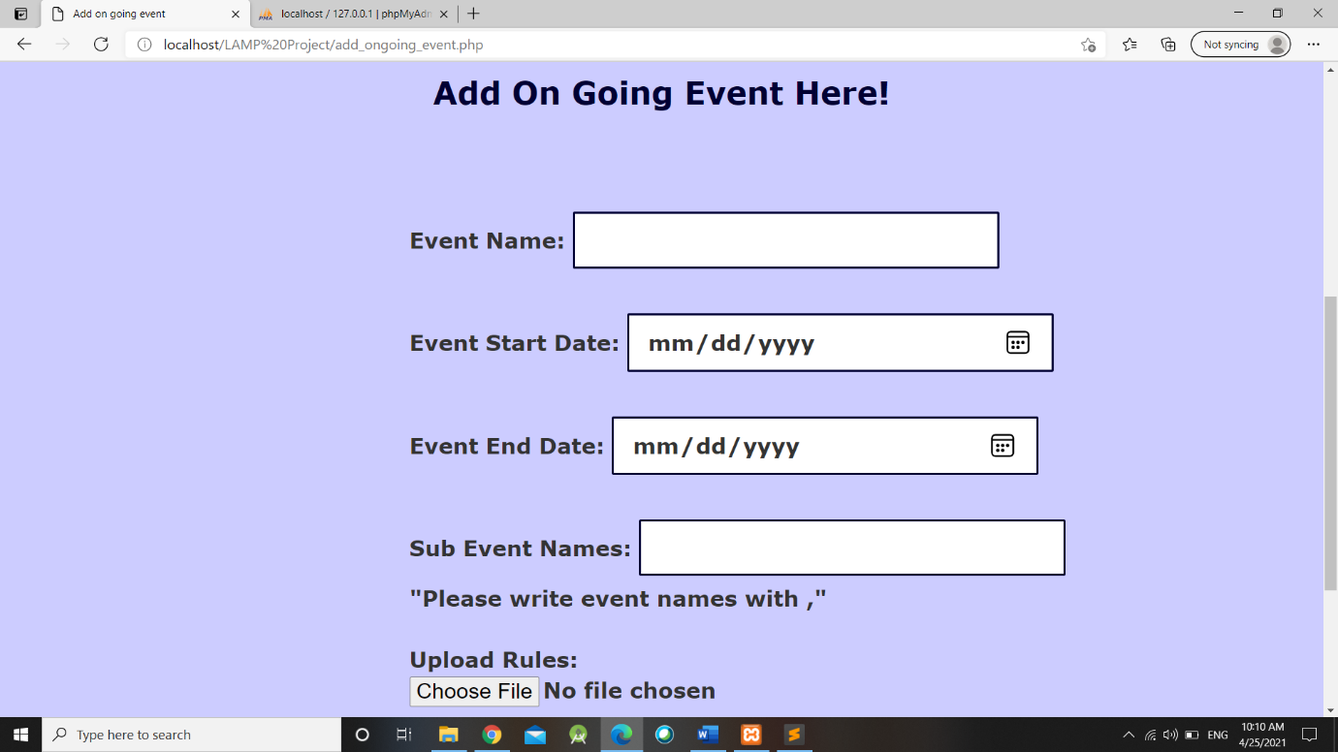

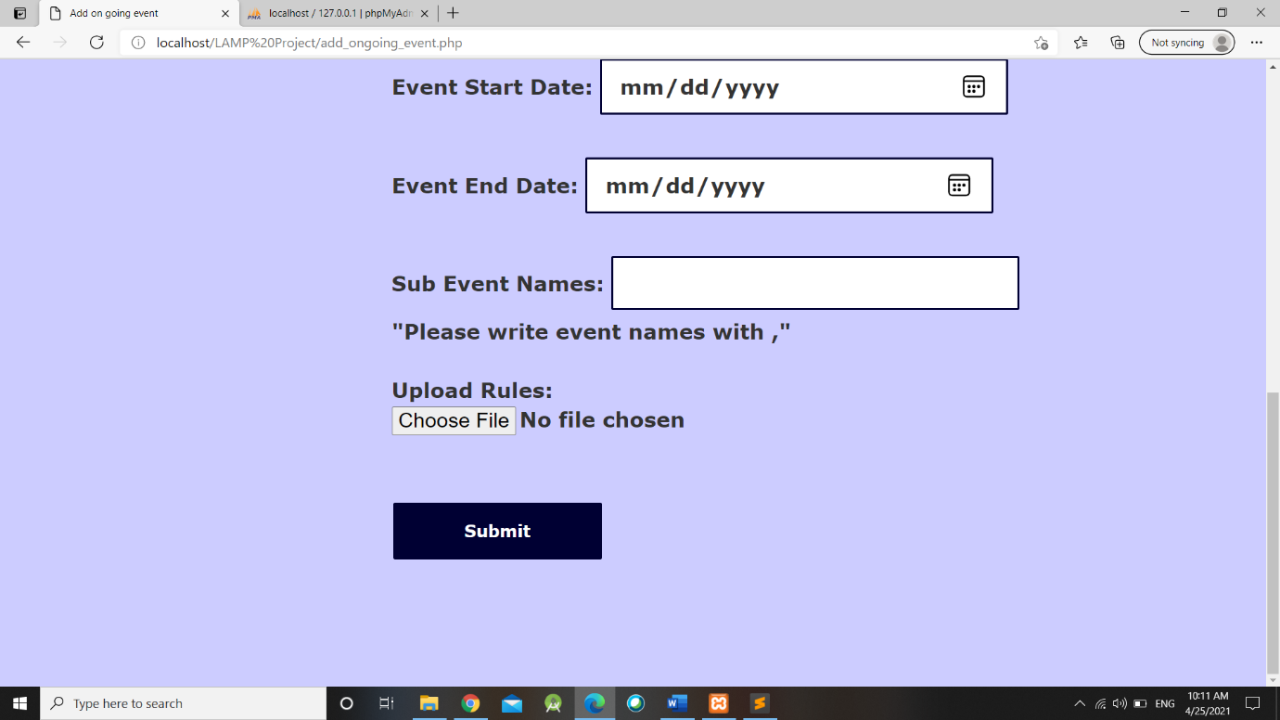

* 1. **Code**

<?php

session_start();

if(isset($_SESSION['loggedin']))

{

echo "<h3>". $_SESSION['username'] . " - " . $_SESSION['utype'] . "</h3>";

}

?>

<?php

include_once('connection.php');

function alertmsg($alt_msg)

{

echo("<script type='text/javascript'>

alert('".$alt_msg."'); </script>");

}

$e_name = $e_sdate = $e_edate= $e_subname= "";

if ($_SERVER["REQUEST_METHOD"] == "POST")

{

$target = "C:/xampp/htdocs/Practicals/LAMP Project/Event_Rules/".basename($_FILES['filename']['name']);

$pdf = $_FILES['filename']['name'];

$e_name = test_input($_POST["e_name"]);

$e_sdate = test_input($_POST["e_sdate"]);

$e_edate = test_input($_POST["e_edate"]);

$e_subname = test_input($_POST["e_subname"]);

$query = "INSERT INTO on_going_event(on_name, on_sdate, on_edate, on_subname, on_pdf) VALUES('$e_name', '$e_sdate','$e_edate','$e_subname',

'$pdf')";

$result = mysqli_query($conn, $query);

move_uploaded_file($_FILES['filename']['tmp_name'], $target);

if($result)

{

$alt_msg = "Event Added Successfully!";

$name = alertmsg($alt_msg);

echo '<script type="text/javascript">window.location.href = "home_1_faculty.php"; </script>';

}

}

function test_input($data)

{

$data = trim($data);

$data = stripslashes($data);

$data = htmlspecialchars($data);

return $data;

}

?>

<center> <h1> <strong style="color:#000033;"> Add On Going Event Here! </strong></h1> </center><br><br>

<div id="ev_w">

<form method="post" action= "add_ongoing_event.php" enctype="multipart/form-data">

Event Name: <input type="text" name="e_name" required>

<br><br>

Event Start Date: <input type="date" name="e_sdate" required>

<br><br>

Event End Date: <input type="date" name="e_edate" required>

<br><br>

Sub Event Names: <input type="text" name="e_subname" required>

<br>

"Please write event names with ,"<br><br>

Upload Rules:

<input type="file" id="myFile" name="filename" required><br><br>

<input type="submit" name="submit" value="Submit">

</form>

</div>

</body>

</html>

1. **Event List - Volunteers**
   1. **Screenshots**

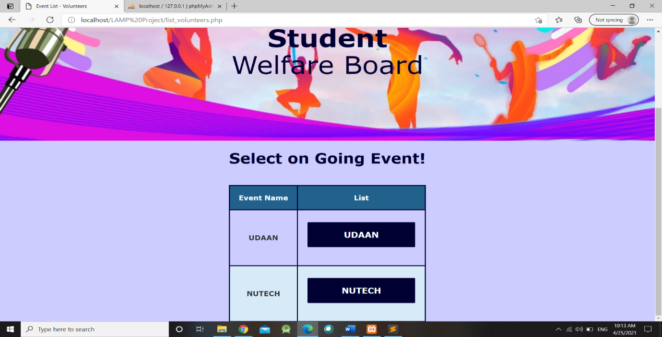

* 1. **Code**

<?php

session_start();

if(isset($_SESSION['loggedin']))

{

echo "<h3>". $_SESSION['username'] . " - " . $_SESSION['utype'] . "</h3>";

}

?>

<?php

include_once('connection.php');

$query = "SELECT * from on_going_event";

$result = mysqli_query($conn, $query);

?>

<center> <h1> <strong style="color:#000033;"> Select on Going Event! </strong></h1> <br><br>

<table>

<tr>

<th> Event Name </th>

<th> List </th>

</tr>

<?php

while($row = mysqli_fetch_array($result))

{

$e = $row['on_name'];

?>

<tr>

<td> <?php echo $e;?> </td>

<td>

<form method="post" action= "list_volunteers_1.php">

<input type="hidden" name="e_name" value="<?php echo $e;?>">

<input type="submit" value="<?php echo $e;?>" name="submit" >

</form>

</td>

</tr>

<?php

}

echo "</table>";

?>

</center>

</body>

</html>

1. **Volunteers List**
   1. **Screenshots**

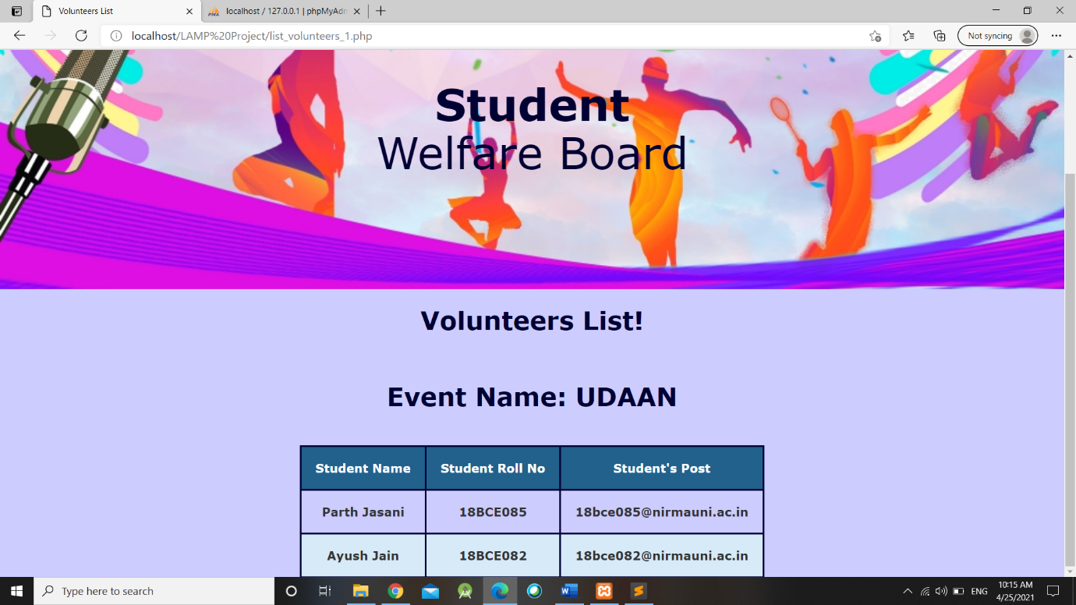

* 1. **Code**

<?php

session_start();

if(isset($_SESSION['loggedin']))

{

echo "<h3>". $_SESSION['username'] . " - " . $_SESSION['utype'] . "</h3>";

}

?>

<?php

include_once('connection.php');

if(isset($_POST['submit']))

{

$e = $_POST['e_name'];

$query = "SELECT * from event_volunteers where v_ename = '$e'";

$result = mysqli_query($conn, $query);

}

<center> <h1> <strong style="color:#000033;"> Volunteers List! </strong></h1> </center><br><br>

<center> <h1> <strong style="color:#000033;"> Event Name: <?php echo $e; ?> </strong></h1> <br><br>

<table>

<tr>

<th> Student Name </th>

<th> Student Roll No </th>

<th> Student's Post </th>

</tr>

<?php

while($row = mysqli_fetch_array($result))

{

?>

<tr>

<td> <?php echo $row['v_sname']; ?> </td>

<td> <?php echo $row['v_rname']; ?> </td>

<td> <?php echo $row['v_email']; ?> </td>

</tr>

<?php

}

echo "</table>";

?>

</center>

</body>

</html>

1. **Event List – Registration** 
   1. **Screenshots**

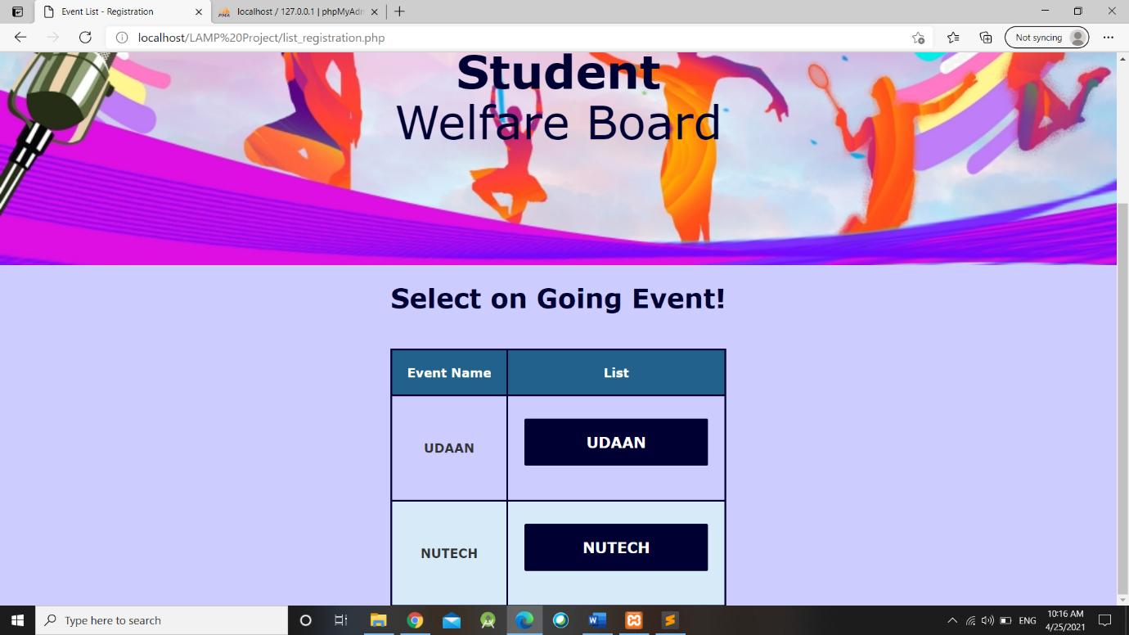

* 1. **Code**

<?php

session_start();

if(isset($_SESSION['loggedin']))

{

echo "<h3>". $_SESSION['username'] . " - " . $_SESSION['utype'] . "</h3>";

}

?>

<?php

include_once('connection.php');

$query = "SELECT * from on_going_event";

$result = mysqli_query($conn, $query);

?>

<center> <h1> <strong style="color:#000033;"> Select on Going Event! </strong></h1> <br><br>

<table>

<tr>

<th> Event Name </th>

<th> List </th>

</tr>

<?php

while($row = mysqli_fetch_array($result))

{

$e = $row['on_name'];

?>

<tr>

<td> <?php echo $e;?> </td>

<td>

<form method="post" action= "list_registration_1.php">

<input type="hidden" name="e_name" value="<?php echo $e;?>">

<input type="submit" value="<?php echo $e;?>" name="submit" >

</form>

</td>

</tr>

<?php

}

echo "</table>";

?>

</center>

</body>

</html>

1. **Registration List**
   1. **Screenshots**

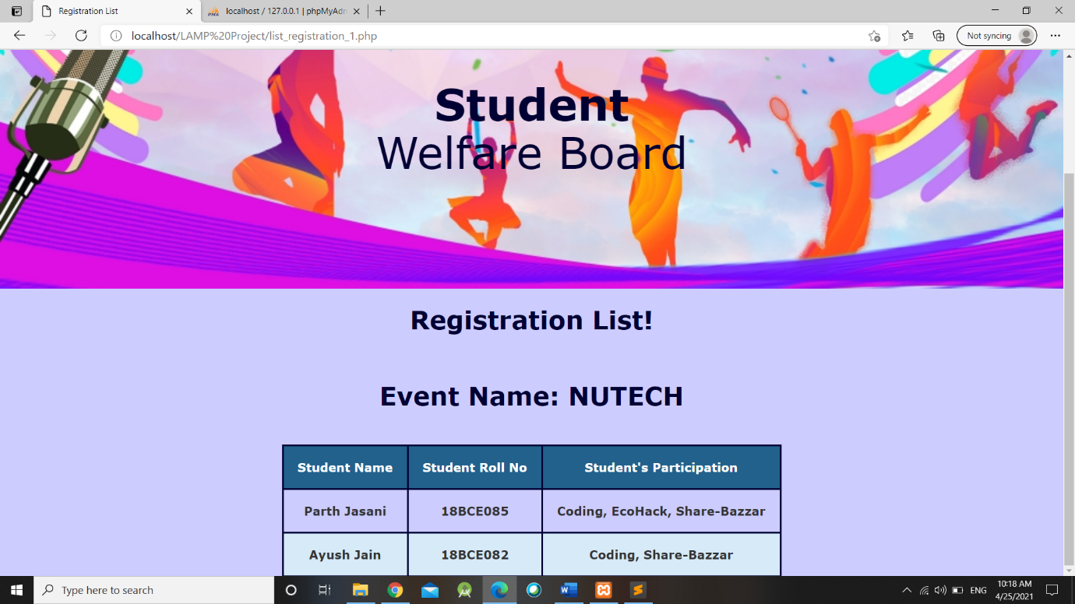

* 1. **Code**

<?php

session_start();

if(isset($_SESSION['loggedin']))

{

echo "<h3>". $_SESSION['username'] . " - " . $_SESSION['utype'] . "</h3>";

}

?>

<?php

include_once('connection.php');

if(isset($_POST['submit']))

{

$e = $_POST['e_name'];

$query = "SELECT * from event_registration where e_name = '$e'";

$result = mysqli_query($conn, $query);

}

<center> <h1> <strong style="color:#000033;"> Registration List! </strong></h1> </center><br><br>

<center> <h1> <strong style="color:#000033;"> Event Name: <?php echo $e; ?> </strong></h1><br><br>

<table>

<tr>

<th> Student Name </th>

<th> Student Roll No </th>

<th> Student's Participation </th>

</tr>

<?php

while($row = mysqli_fetch_array($result))

{

?>

<tr>

<td> <?php echo $row['s_name']; ?> </td>

<td> <?php echo $row['s_roll']; ?> </td>

<td> <?php echo $row['r_subname']; ?> </td>

</tr>

<?php

}

echo "</table>";

?>

</center>

</body>

</html>

1. **Student Welfare - Admin**
   1. **Screenshots**



* 1. **Code**

<?php

session_start();

if(isset($_SESSION['loggedin']))

{

echo "<h3>". $_SESSION['username'] . " - " . $_SESSION['utype'] . "</h3>";

}

?>

<center> <h1> <strong style="color:#000033;"> Welcome to Student Welfare Board! </strong></h1> </center><br><br>

<div style="padding: 20px; margin: 20px;">

<p> <h2> Hello Everyone! Welcome to the Student Welfare Board of XYZ University. Student Welfare Board was established in the year of 2004. Student Welfare Board is working on different activities like sports, clutural, technical, social etc.</h2></p><br><br>

</div>

<div class="slideshow-container">

<div class="mySlides fade">

<div class="numbertext">1 / 3</div>

<img src="lp3.jpg" style="width:100%; height: 100%;">

<div class="text">Dancing</div>

</div>

<div class="mySlides fade">

<div class="numbertext">2 / 3</div>

<img src="lp4.jpg" style="width:100%; height: 100%;">

<div class="text">Singing</div>

</div>

<div class="mySlides fade">

<div class="numbertext">3 / 3</div>

<img src="lp5.jpg" style="width:100%;height: 100%;">

<div class="text">Acting</div>

</div>

</div>

<br>

<div style="text-align:center">

<span class="dot"></span>

<span class="dot"></span>

<span class="dot"></span>

</div>

<script>

var slideIndex = 0;

showSlides();

function showSlides() {

var i;

var slides = document.getElementsByClassName("mySlides");

var dots = document.getElementsByClassName("dot");

for (i = 0; i < slides.length; i++) {

slides[i].style.display = "none";

}

slideIndex++;

if (slideIndex > slides.length) {slideIndex = 1}

for (i = 0; i < dots.length; i++) {

dots[i].className = dots[i].className.replace(" active", "");

}

slides[slideIndex-1].style.display = "block";

dots[slideIndex-1].className += " active";

setTimeout(showSlides, 3000); // Change image every 2 seconds

}

</script>

</body>

</html>

1. **Event Calendar for Student Welfare**
   1. **Screenshots**

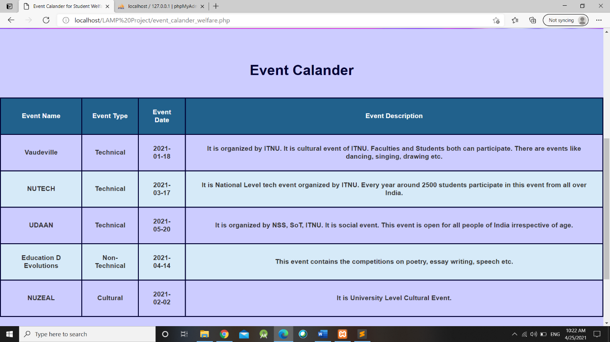

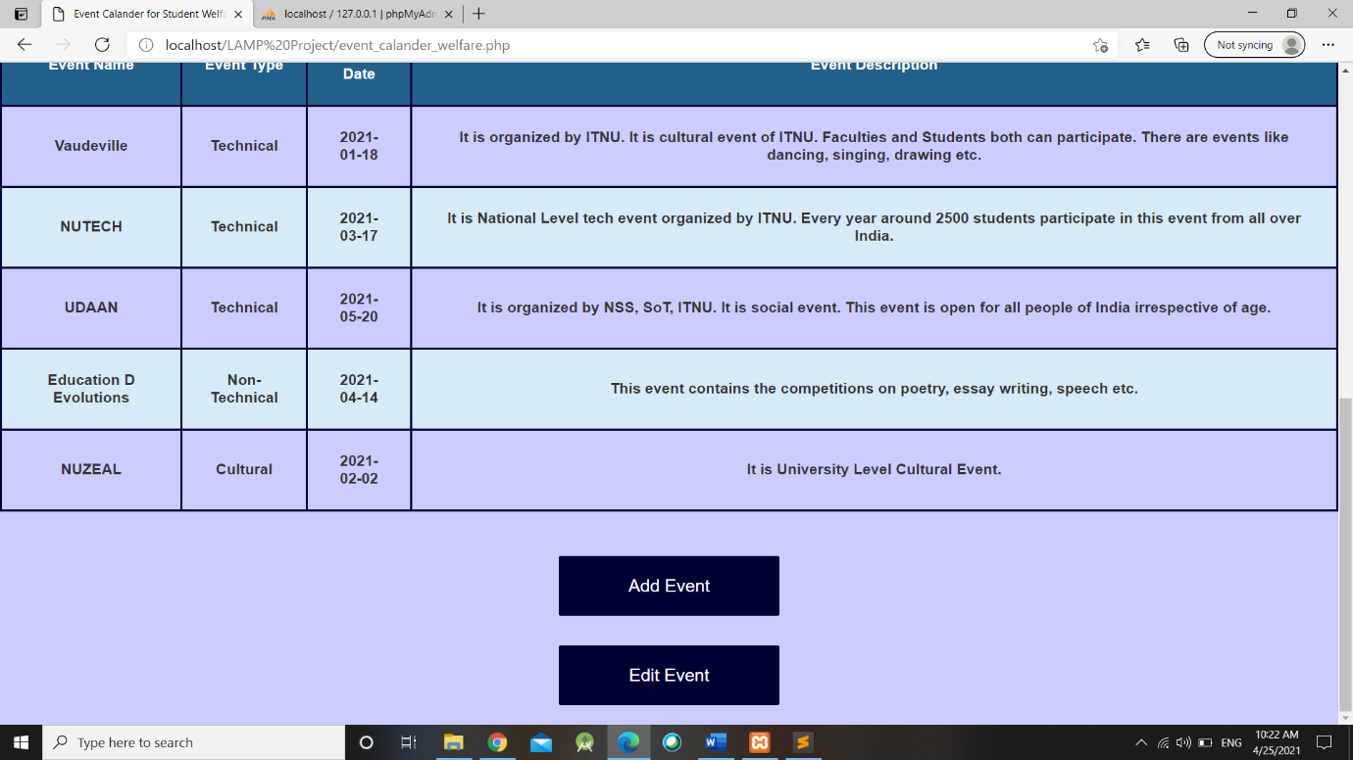

* 1. **Code**

<?php

session_start();

if(isset($_SESSION['loggedin']))

{

echo "<h3>". $_SESSION['username'] . " - " . $_SESSION['utype'] . "</h3>";

}

?>

<?php

include_once('connection.php');

$query = "select * from event_calander";

$result = mysqli_query($conn, $query);

?>

<center> <h1><strong style="color:#000033;"> Event Calander </strong> </h1> <br> <br>

<table>

<tr>

<th> Event Name </th>

<th> Event Type </th>

<th> Event Date </th>

<th> Event Description </th>

</tr>

<?php

$count = 0;

while($row = mysqli_fetch_array($result))

{

echo "<tr>";

echo "<td>" . $row['event_name'] ."</td>";

echo "<td>" . $row['event_type'] ."</td>";

echo "<td>" . $row['event_month'] ."</td>";

echo "<td>" . $row['event_desc'] ."</td>";

echo "</tr>";

$count++;

}

?>

</table>

<br><br>

<form method='post' action="event_calander_welfare_add.php">

<input type='submit' value='Add Event' name='add'>

<input type='hidden' value='<?php echo $count ?>' name='count'>

</form>

<form method='post' action='event_calander_welfare_edit.php'>

<input type='submit' value='Edit Event' name='edit'>

</form>

</center>

</body>

</html>

1. **Add Form for Event Calendar** 
   1. **Screenshots**

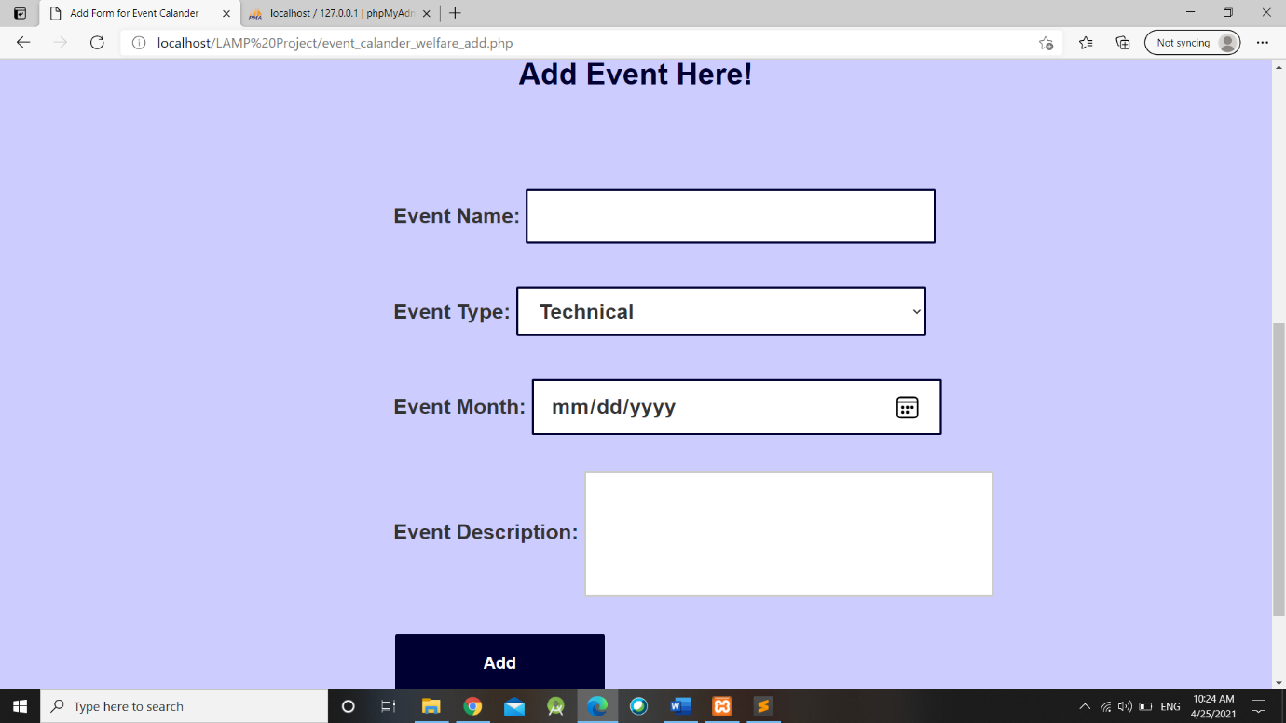

* 1. **Code**

<?php

session_start();

if(isset($_SESSION['loggedin']))

{

echo "<h3>". $_SESSION['username'] . " - " . $_SESSION['utype'] . "</h3>";

}

?>

<center>

<?php

include_once('connection.php');

if(isset($_POST['add']))

{

$temp = $_POST['count'];

$temp++;

$e_id = 'EV' . $temp;

}

if(isset($_POST['eadd']))

{

//prompt function

function alertmsg($alt_msg)

{

echo("<script type='text/javascript'>

alert('".$alt_msg."'); </script>");

}

$eid = $_POST['eid'];

$ename = $_POST['ename'];

$etype = $_POST['etype'];

$edate = $_POST['edate'];

$edesc = $_POST['edesc'];

#echo $eid . $ename . $etype . $edate . $edesc;

$query = "insert into event_calander(event_id, event_name, event_type, event_month, event_desc) values('$eid', '$ename', '$etype', '$edate', '$edesc')";

$result = mysqli_query($conn, $query);

if ($result)

{

$nrows=mysqli_affected_rows($conn);

if($nrows>0)

{

$alt_msg = "Successfully Added Event!";

$name = alertmsg($alt_msg);

echo '<script type="text/javascript">window.location.href = "event_calander_welfare.php"; </script>';

//header("Location: http://localhost:8080/PHP6/8.html");

exit;

}

}}?>

<h1><strong style="color:#000033;"> Add Event Here! </strong> </h1><br> <br> </center>

<div id="ev_w">

<form method="post" action='event_calander_welfare_add.php'>

<strong> Event Name: <input type='text' name='ename' required><br><br>

Event Type: <select name='etype' required>

<option value='Technical'> Technical </option>

<option value='Non-Technical'> Non-Technical </option>

<option value='Cultural'> Cultural </option>

<option value='Social'> Social </option>

</select> <br><br>

Event Month: <input type='date' name='edate' required><br><br>

Event Description: <input type='textarea' name='edesc'></strong><br> <br>

<input type='submit' value='Add' name='eadd'>

<input type='hidden' value='<?php echo $e_id ?>' name='eid'>

</form>

</div>

</body>

</html>

1. **Edit in Event Calendar** 
   1. **Screenshots**

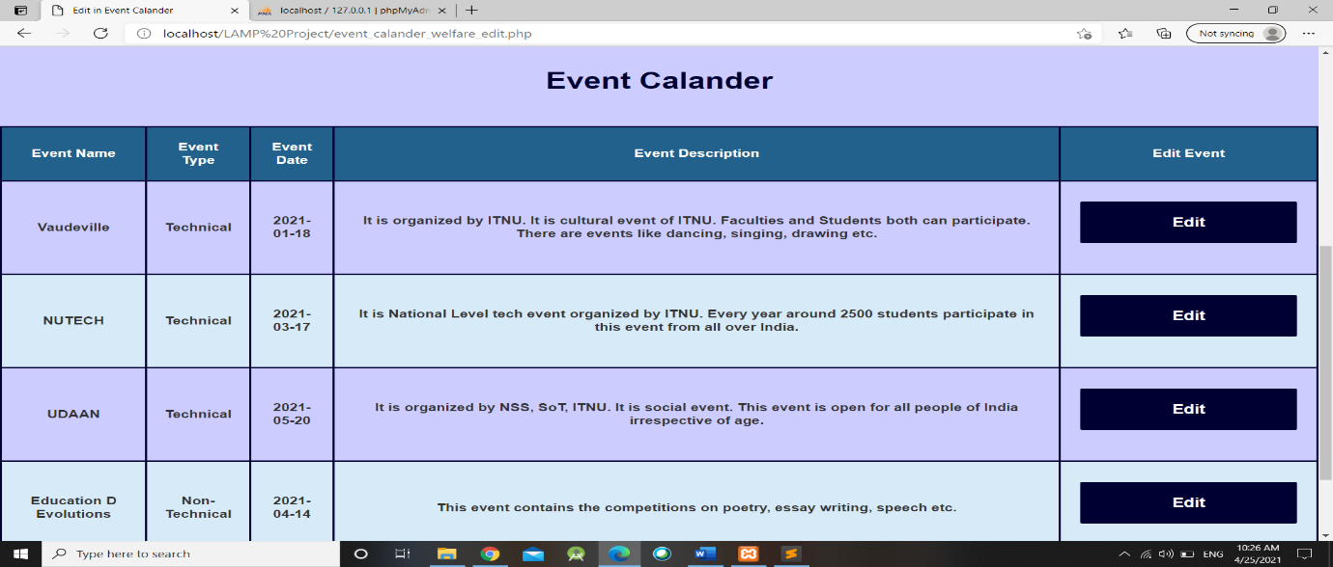

* 1. **Code**

<?php

session_start();

if(isset($_SESSION['loggedin']))

{

echo "<h3>". $_SESSION['username'] . " - " . $_SESSION['utype'] . "</h3>";

}

?>

<?php

include_once('connection.php');

$query = "select * from event_calander";

$result = mysqli_query($conn, $query);

?>

<center> <h1> <strong style="color:#000033;"> Event Calander </strong> </h1> <br> <br>

<table>

<tr>

<th> Event Name </th>

<th> Event Type </th>

<th> Event Date </th>

<th> Event Description </th>

<th> Edit Event </th>

</tr>

<?php

while($row = mysqli_fetch_array($result))

{

echo "<tr>";

echo "<td>" . $row['event_name'] ."</td>";

echo "<td>" . $row['event_type'] ."</td>";

echo "<td>" . $row['event_month'] ."</td>";

echo "<td>" . $row['event_desc'] ."</td>";

$eid = $row['event_id'];

echo "<td>" . "<form method='post' action='event_calander_welfare_edit_verify.php'>". "<input type='submit' value='Edit' name='e_edit'>"."<input type='hidden' value='$eid' name='eid'>" . "</form>" ."</td>";

echo "</tr>";

}

?>

</table>

</center>

</body>

</html>

1. **Edit Form for Event Calendar** 
   1. **Screenshots**

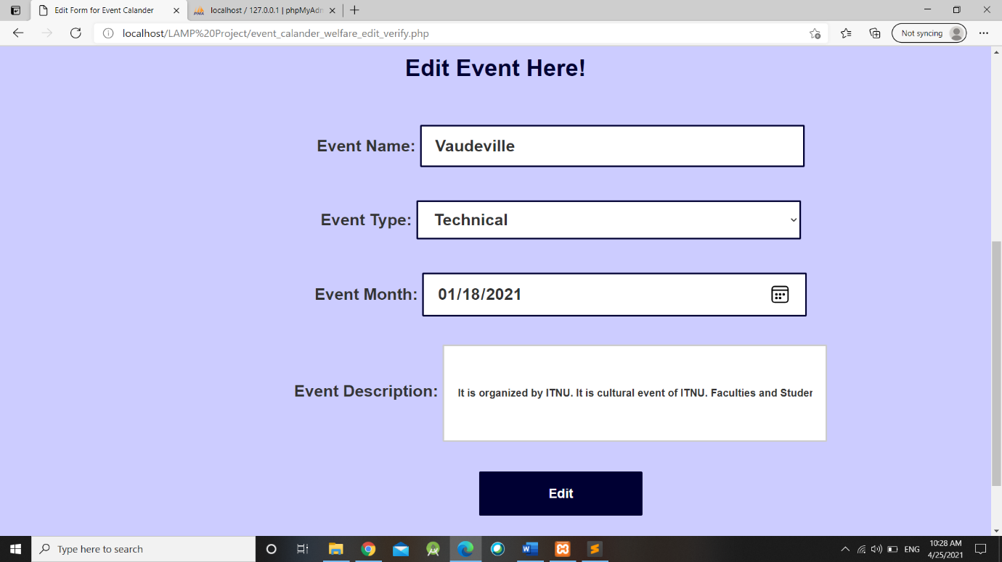

* 1. **Code**

<?php

session_start();

if(isset($_SESSION['loggedin']))

{

echo "<h3>". $_SESSION['username'] . " - " . $_SESSION['utype'] . "</h3>";

}

?>

<center>

<?php

include_once('connection.php');

if(isset($_POST['e_edit']))

{

$eid = $_POST['eid'];

$query = "select * from event_calander where event_id = '$eid' ";

$result = mysqli_query($conn, $query) or die( mysqli_error($conn));

while($row = mysqli_fetch_array($result))

{

$eid = $row['event_id'];

$ename = $row['event_name'];

$etype = $row['event_type'];

$edate = $row['event_month'];

$edesc = $row['event_desc'];

#echo $eid . $ename . $etype . $edate . $edesc;

}}

if(isset($_POST['eedit']))

{

function alertmsg($alt_msg)

{

echo("<script type='text/javascript'>

alert('".$alt_msg."'); </script>");

}

$eid = $_POST['eid'];

$ename = $_POST['ename'];

$etype = $_POST['etype'];

$edate = $_POST['edate'];

$edesc = $_POST['edesc'];

#echo $eid . $ename . $etype . $edate . $edesc;

$query = "UPDATE event_calander SET event_name='$ename', event_type='$etype', event_month='$edate', event_desc='$edesc' WHERE event_id='$eid'";

$result = mysqli_query($conn, $query) or die( mysqli_error($conn));

if ($result)

{

$nrows=mysqli_affected_rows($conn);

if($nrows>0)

{

$alt_msg = "Successfully Edited Event!";

$name = alertmsg($alt_msg);

echo '<script type="text/javascript">window.location.href = "event_calander_welfare.php"; </script>';

//header("Location: http://localhost:8080/PHP6/8.html");

exit;

}

}

}

?>

<h1> <strong style="color:#000033;"> Edit Event Here! </strong> </h1>

<div id="ev_w">

<form method="post" action='event_calander_welfare_edit_verify.php'>

Event Name: <input type='text' name='ename' value="<?php echo $ename; ?>" readonly required><br><br>

Event Type: <select name='etype' value="<?php echo $etype; ?>" required>

<option value='Technical'> Technical </option>

<option value='Non-Technical'> Non-Technical </option>

<option value='Cultural'> Cultural </option>

<option value='Social'> Social </option>

</select> <br><br>

Event Month: <input type='date' name='edate' value="<?php echo $edate; ?>" required><br><br>

Event Description: <input type='textarea' name='edesc' value="<?php echo $edesc; ?>"><br><br>

<input type='hidden' value='<?php echo $eid;?>' name='eid'>

<center> <input type='submit' value='Edit' name='eedit'> </center>

</form>

</div>

</center>

</body>

</html>

1. **Edit Photos**
   1. **Screenshots**

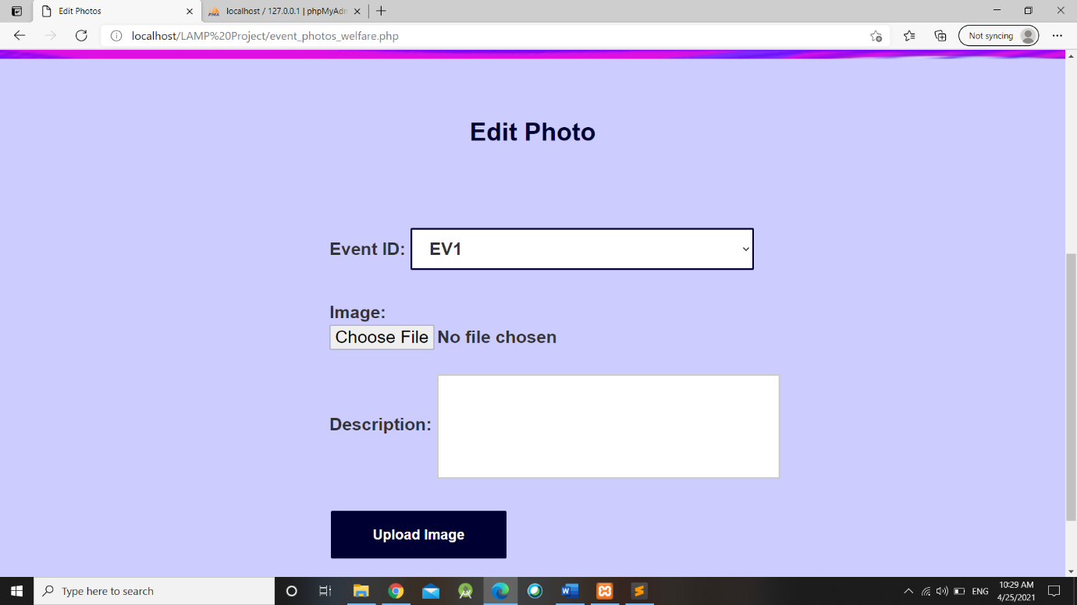

* 1. **Code**

<?php

session_start();

if(isset($_SESSION['loggedin']))

{

echo "<h3>". $_SESSION['username'] . " - " . $_SESSION['utype'] . "</h3>";

}

?>

<?php

include_once('connection.php');

$query_d = "SELECT * FROM event_calander";

$result = mysqli_query($conn, $query_d);

if(isset($_POST['upload']))

{

function alertmsg($alt_msg)

{

echo("<script type='text/javascript'>

alert('".$alt_msg."'); </script>");

}

$target = "C:/xampp/htdocs/Practicals/LAMP Project/Event_Photos/".basename($_FILES['image_path']['name']);

$image = $_FILES['image_path']['name'];

$eid = $_POST['image_event_id'];

$desc = $_POST['image_desc'];

$query = "INSERT INTO event_images(image_event_id, image_path, image_desc) VALUES('$eid', '$image', '$desc')";

$result = mysqli_query($conn, $query);

move_uploaded_file($_FILES['image_path']['tmp_name'], $target);

if($result)

{

$alt_msg = "Successfully Uploaded Image!";

$name = alertmsg($alt_msg);

echo '<script type="text/javascript">window.location.href = "event_photos_welfare.php"; </script>';

}}

?>

<center> <h1> <strong style="color:#000033;"> Edit Photo </strong> </h1> <br> <br></center>

<div id="ev_w">

<form method="post" action="event_photos_welfare.php" enctype="multipart/form-data">

Event ID: <select name="image_event_id" required>

<?php

while($row = mysqli_fetch_array($result))

{

$id = $row['event_id'];

?>

<option value="<?php echo $id;?>"><?php echo $id;?> </option>

<?php

}

?>

</select>

<br><br>

Image: <input type="file" name="image_path" required><br>

Description: <input type="textarea" name="image_desc" required> <br><br>

<input type="submit" value="Upload Image" name="upload">

</form>

</div>

</body>

</html>

**Screenshots of Data Base**

1. **event_calander**

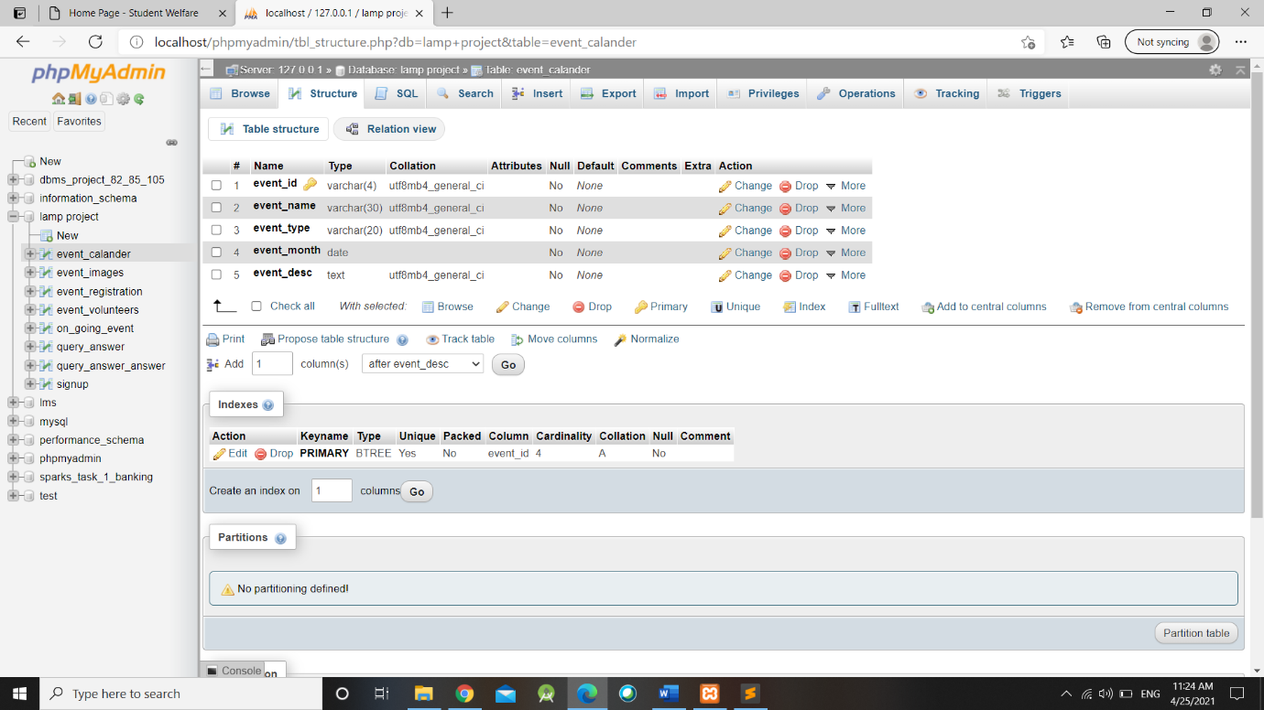

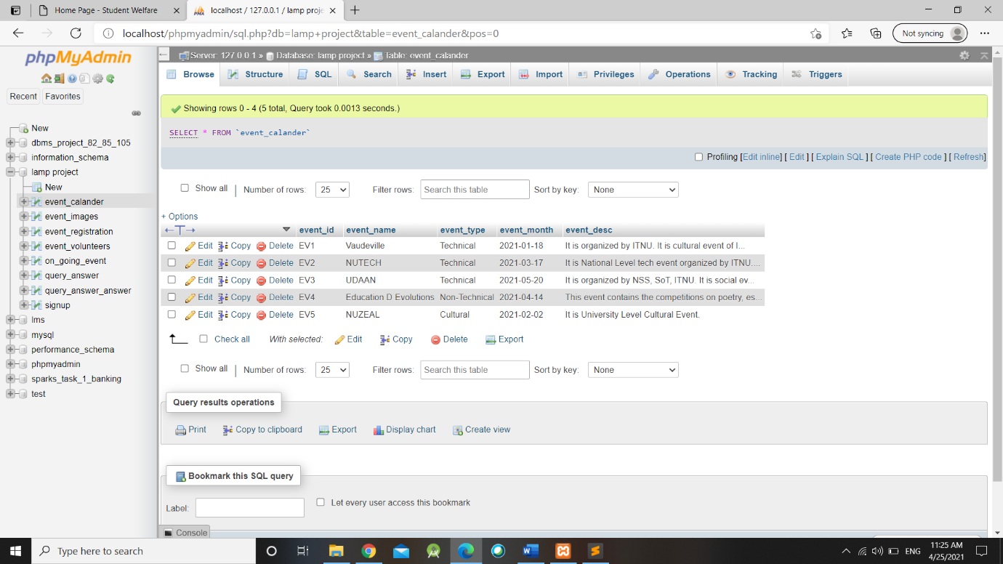

1. **event_images**

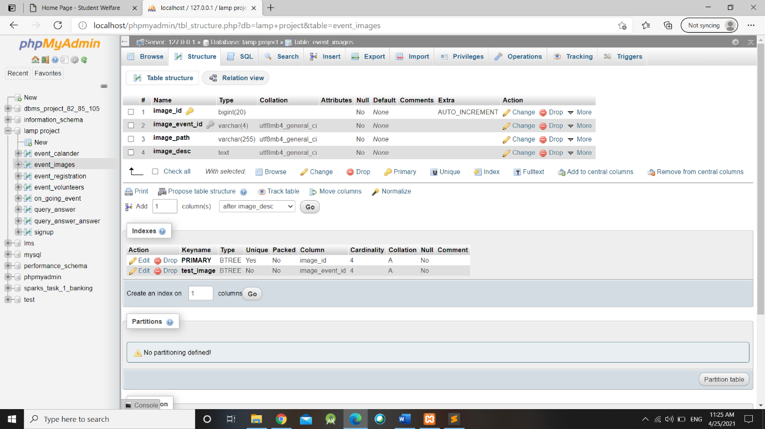

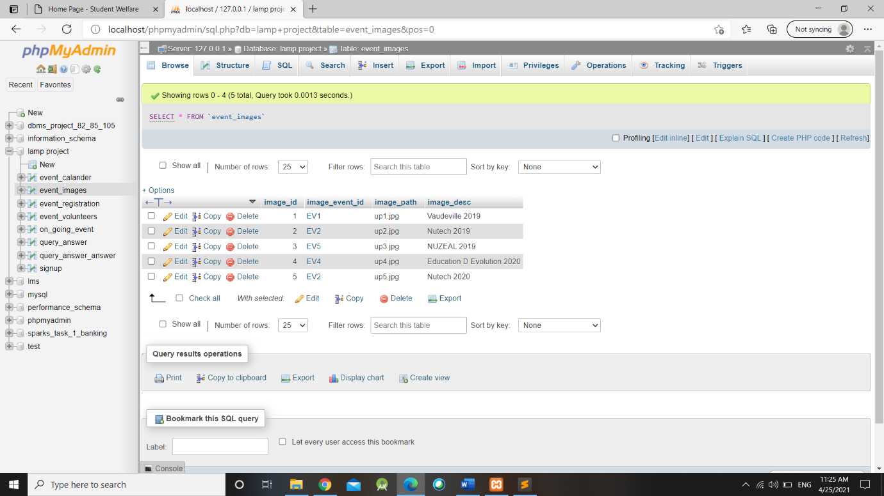

1. **event_registration**

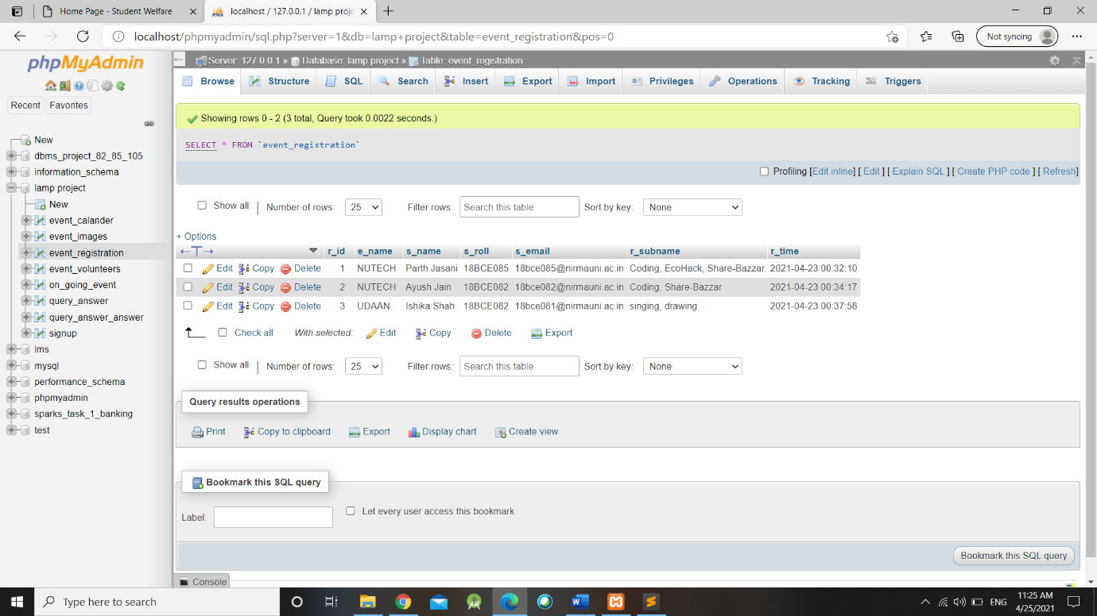

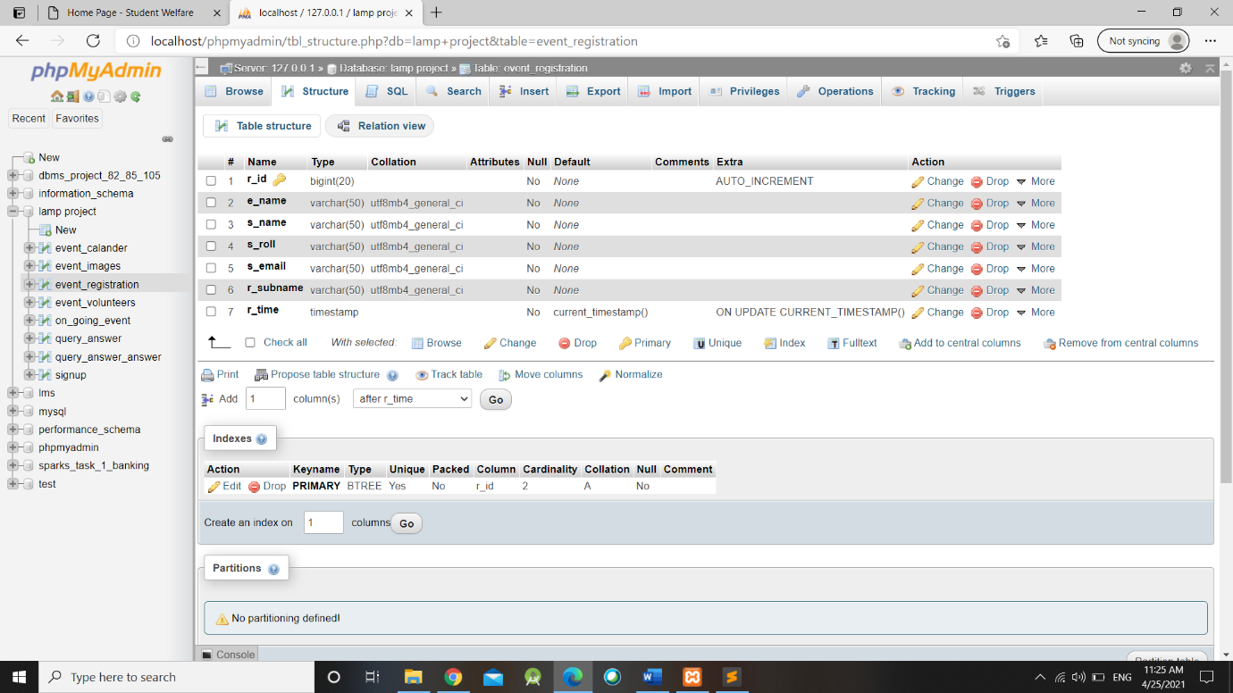

1. **event_volunteers**

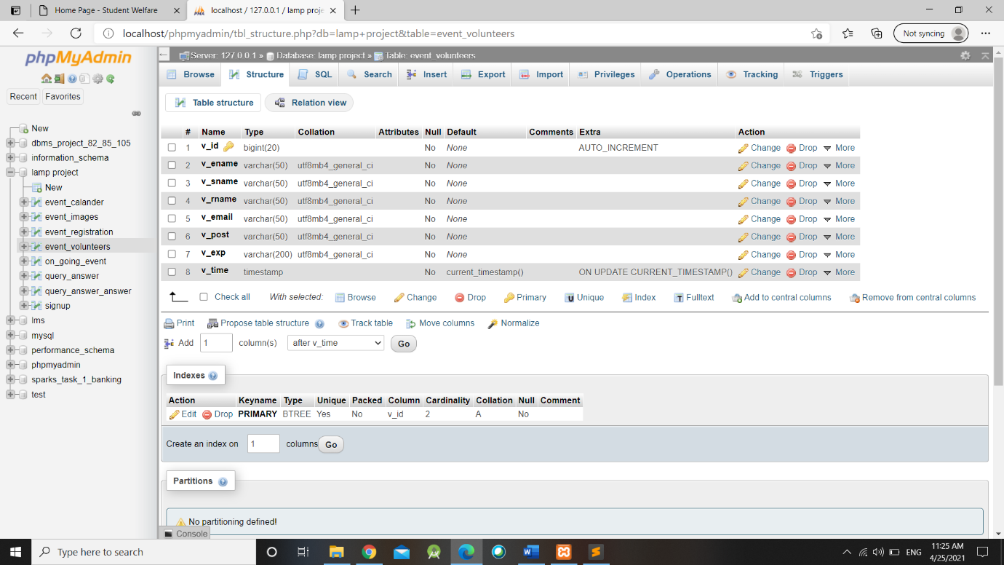

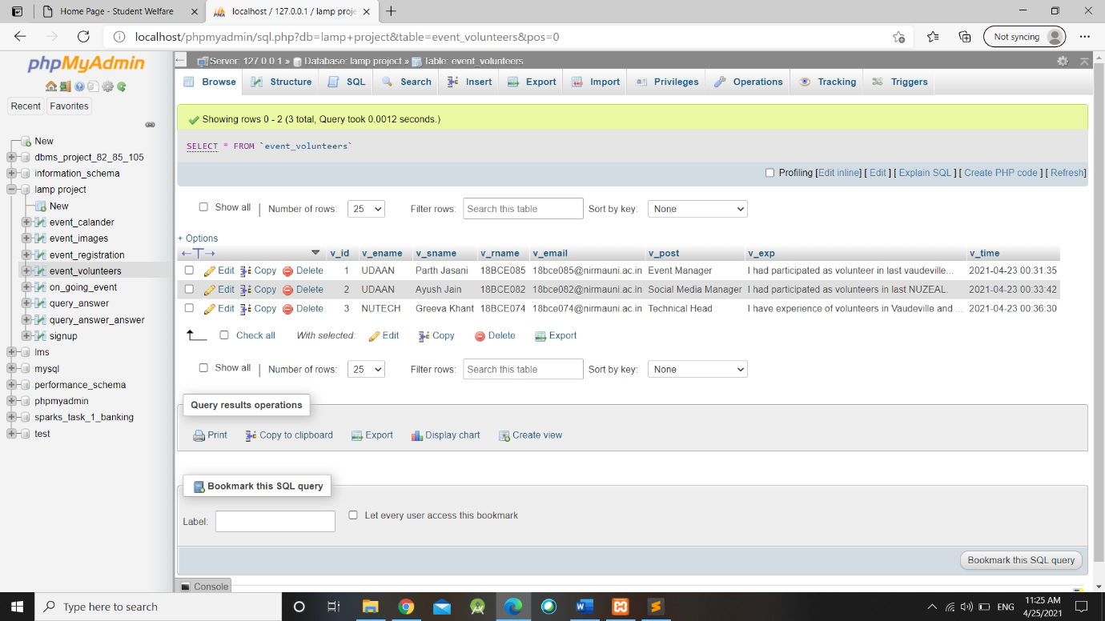

1. **on_going_event**

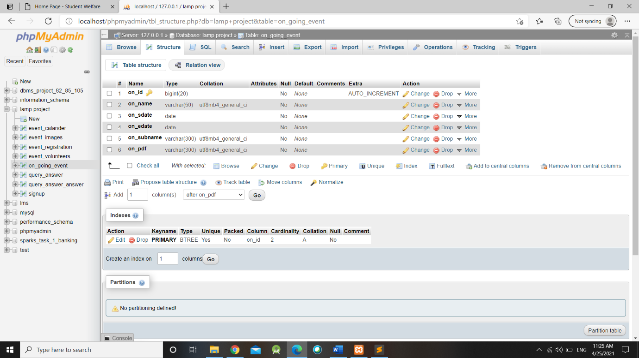

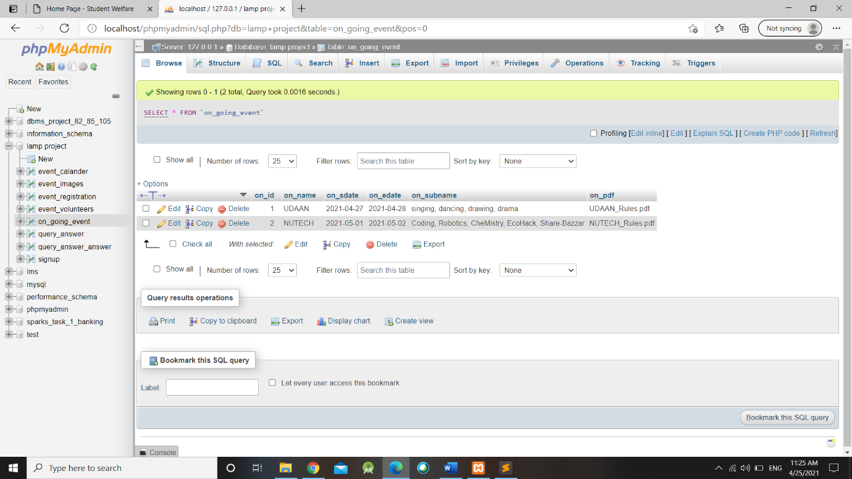

1. **query_answer**

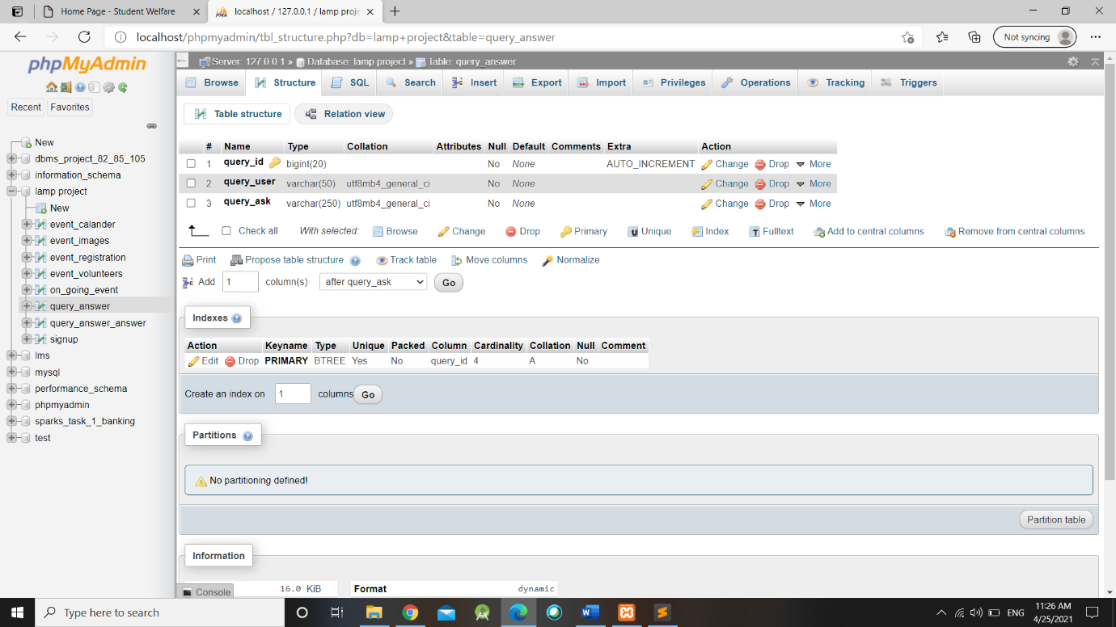

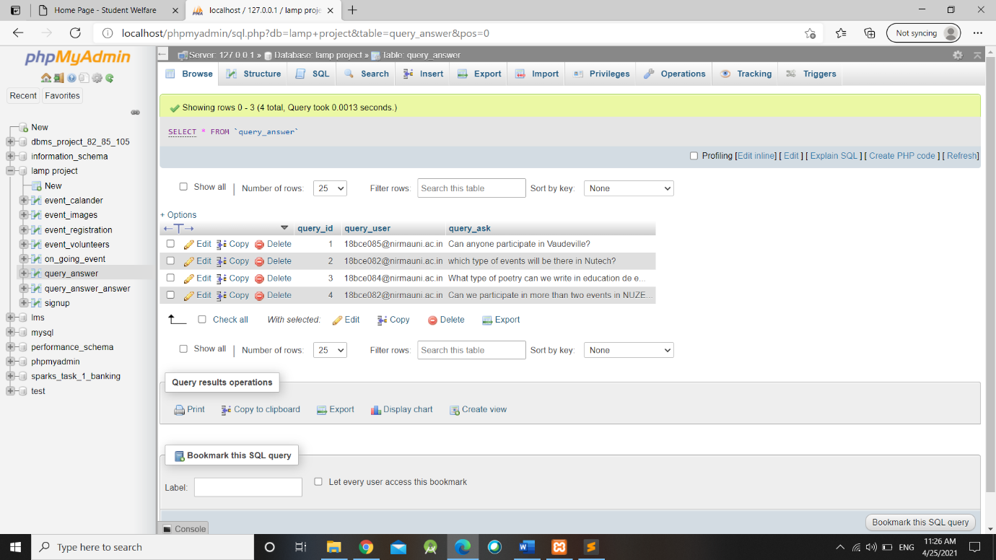

1. **query_answer_answer**

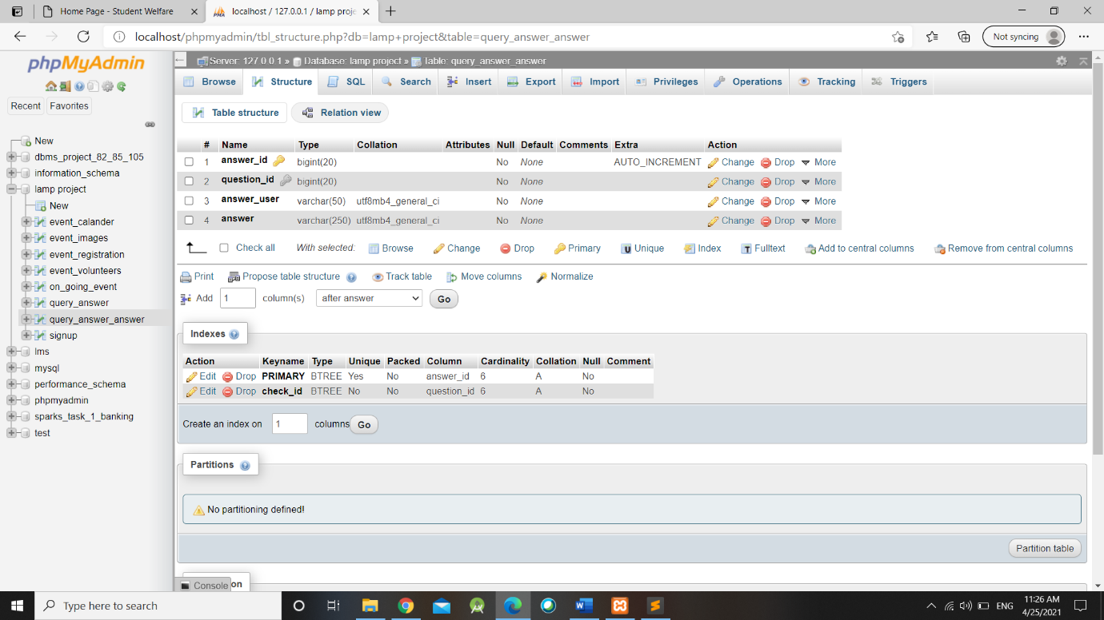

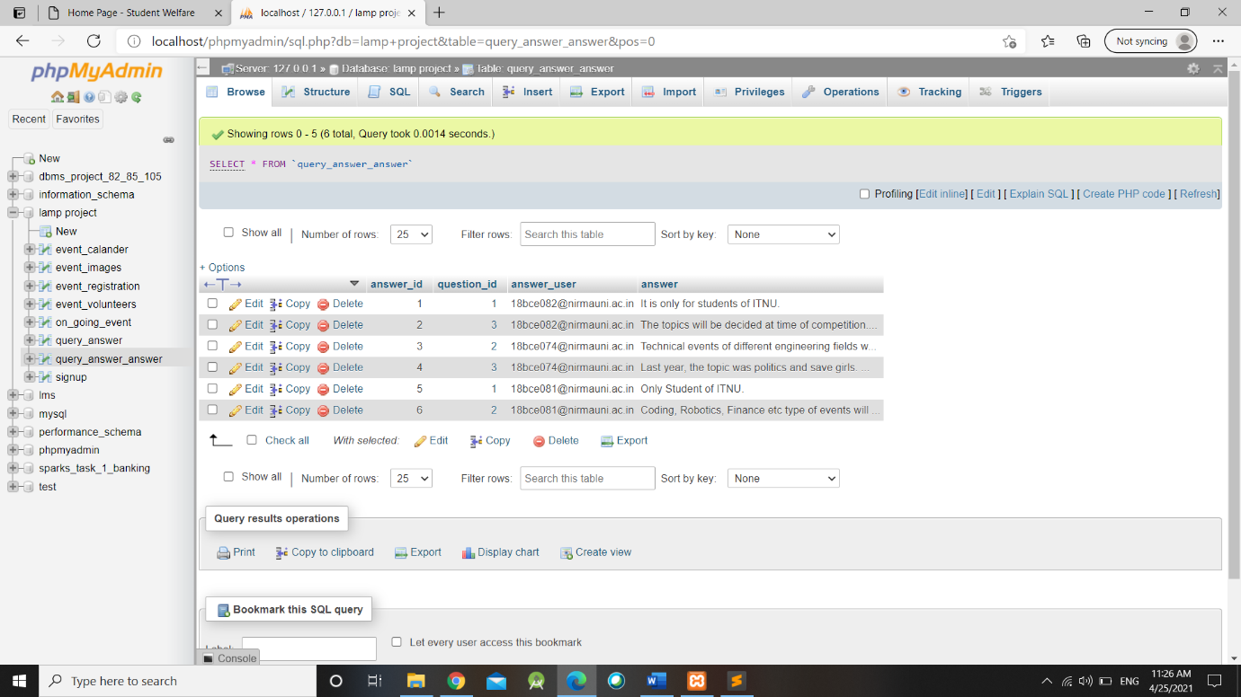

1. **signup**

